Lola is telling Ms. Clark about her day at the shopping mall and about her friends. Where did each person go? Listen and write a letter in each box.  5
1
 | 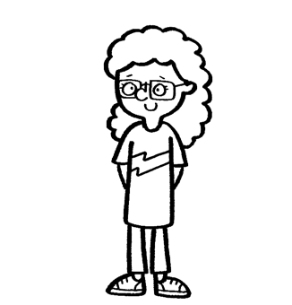  1  B  2 | Paula | 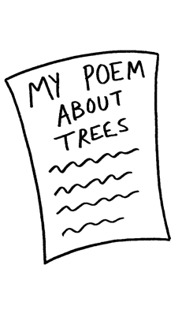  A  C | 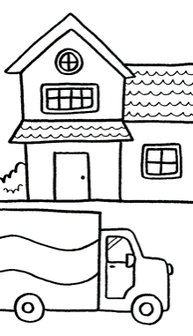
 | 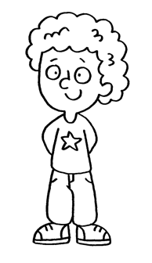 | Alex | 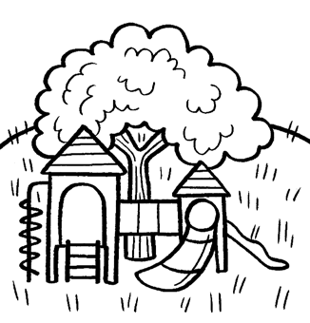  D | 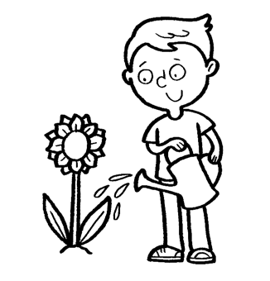
 | 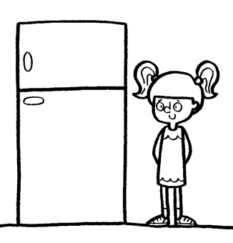  3 | Gemma | 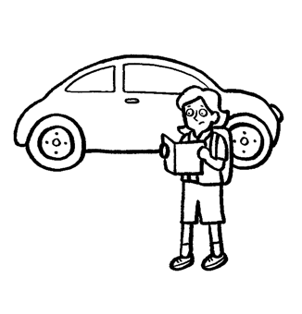  G  E | 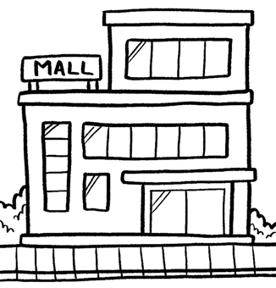  F
 | 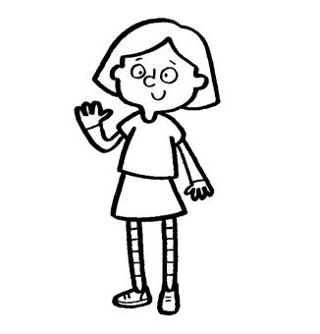  4 | Karen | 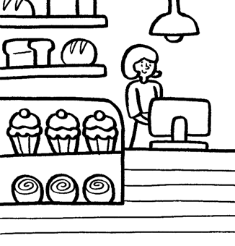 | 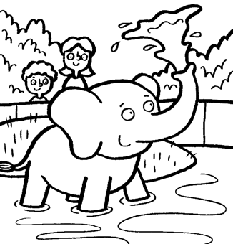  H
 | 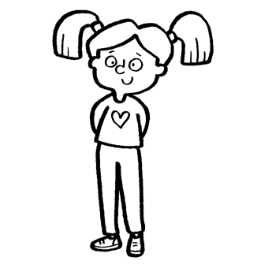  5 | Nadia | 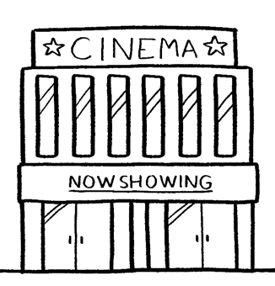  I  J | 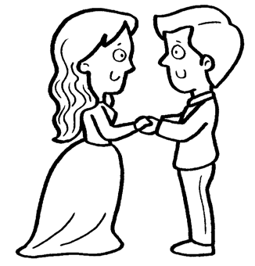

Read the text. Choose the right words and write them
on the lines.
1
2
Sport
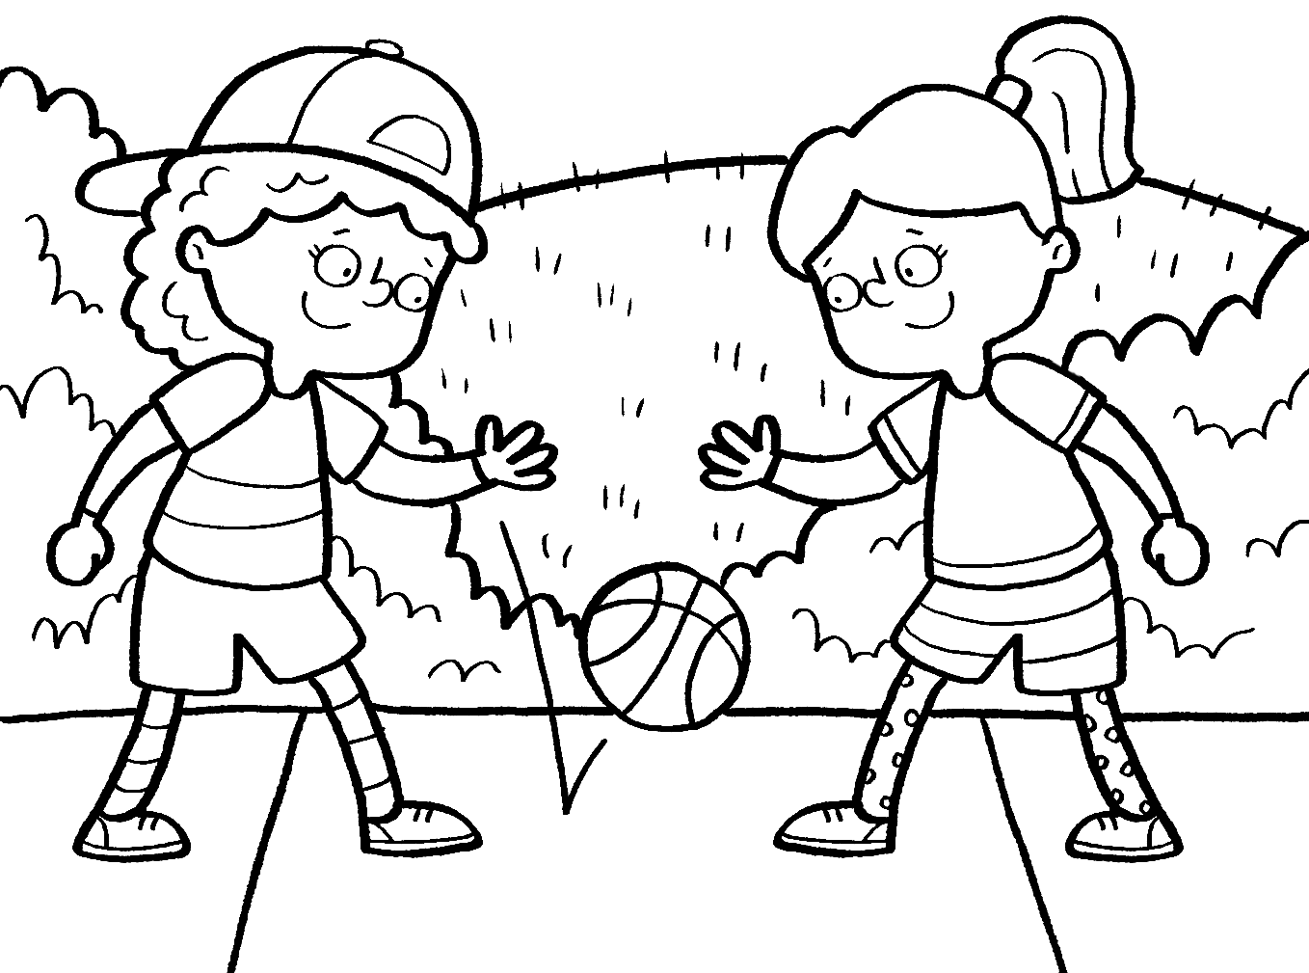
Do you like _______________ sport? Some children play sport _______________ school. They play in hockey or soccer teams, and they play matches with other teams. They try to win the match. Some children like to play with _______________ friends. They bounce or throw balls or skip _______________ the park. Some children like to
_______________ an activity alone. They hike or ride a horse.
Sport is a fun and healthy thing to do.
4
5
3
2
1 play playing played
2 at in on
3 their there they’re
4 on in around
5 do doing did
Look and read. Choose the correct words and
write them on the lines.
3
laugh thermometer zoo butterfly stream
1 This is a place where we can see animals. _______________
2 This is an insect with big, colourful wings. _______________
3 This is something you do when you think
something is funny. _______________
4 You use this to take your temperature when
you are sick. _______________
5 This is a very small river. _______________

Read the text and choose the best answer. Mia is talking to
her friend Bella.
4
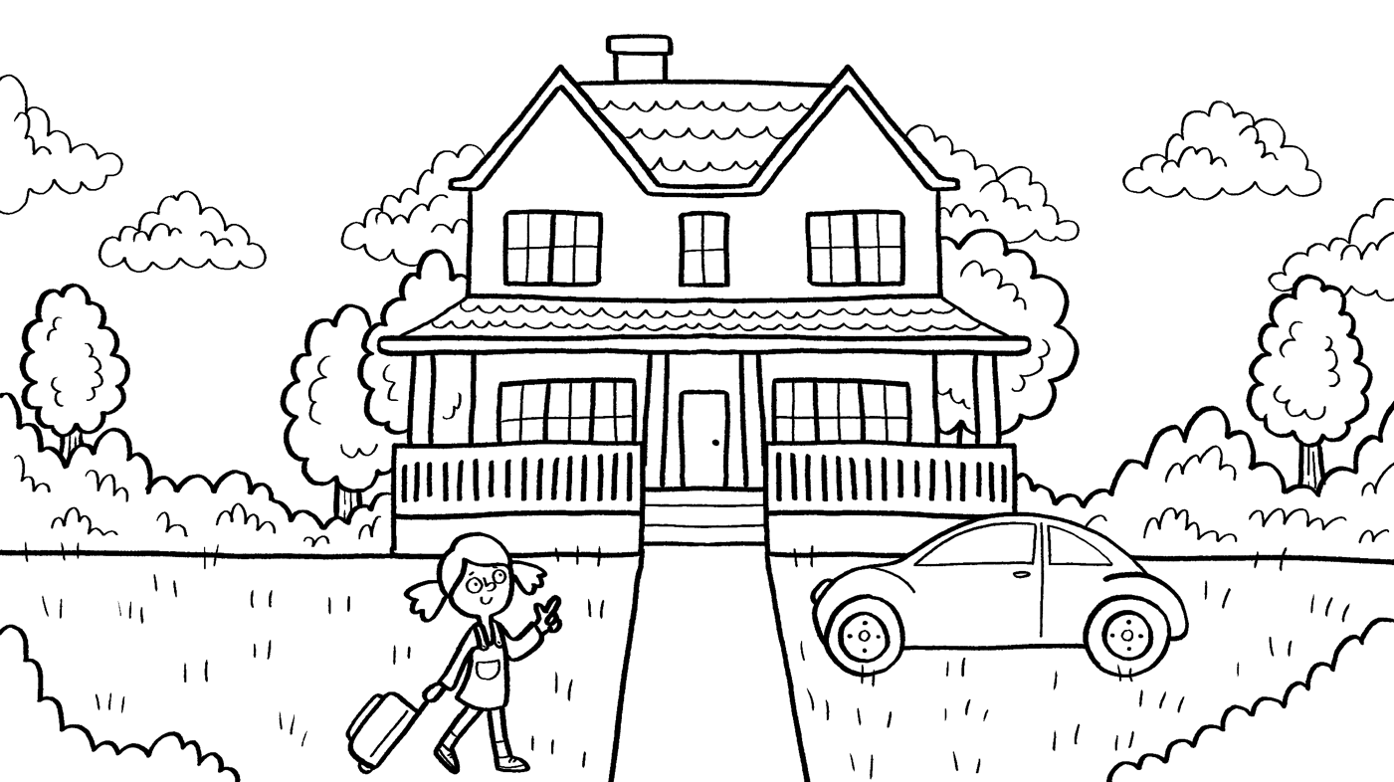
1 Mia: What did you do last weekend?
Bella: A My family move house.
B My family moved to house.
C My family moved house.
2 Mia: Where did you move?
Bella: A We moved to a house in the suburbs.
B We moved to house in the suburbs.
C We moved to a house in the suburb.
3 Mia: Did you help your family?
Bella: A No, I did.
B Yes, I did.
C Yes, I do.
4 Mia: What did you do?
Bella: A I pack boxes.
B I packed boxes.
C I’m packing boxes.
5 Mia: Do you like your new house?
Bella: A Yes. I think it’s great.
B Yes. I don’t like it.
C No. I think it’s great.

Look, find, and circle the different ones.
5
 | 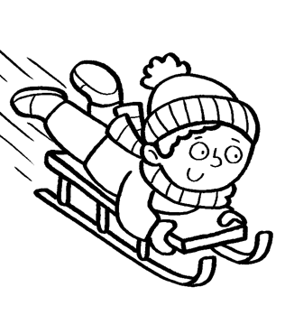  1 | 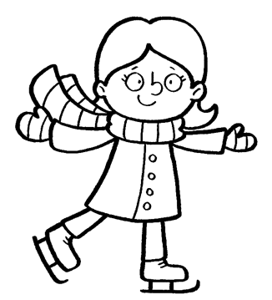 | 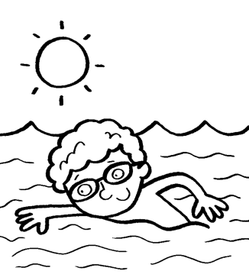 | 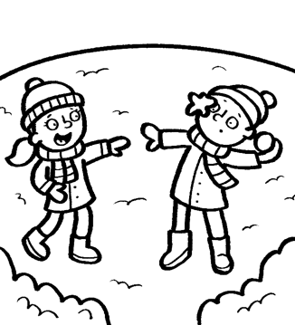
 | 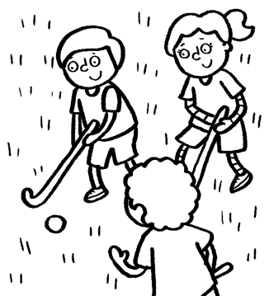  3  2 | 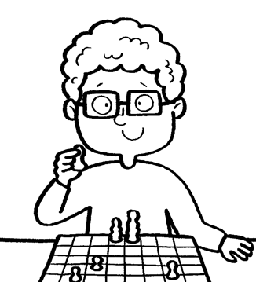 | 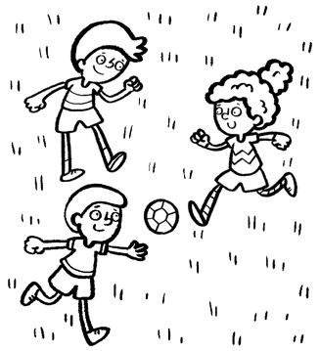 | 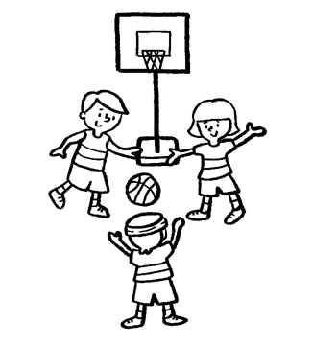
 | 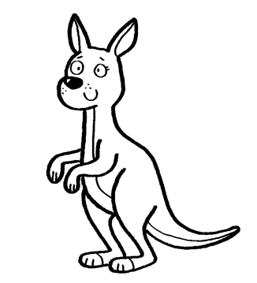 | 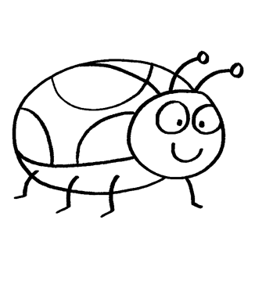 | 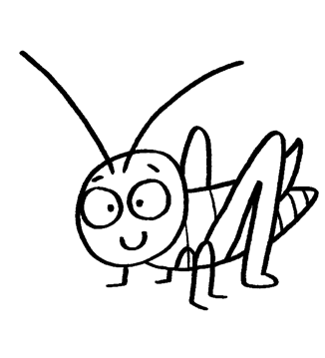 | 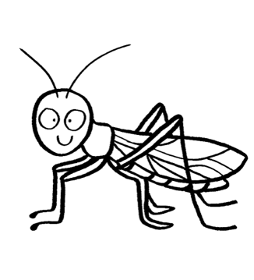
 | 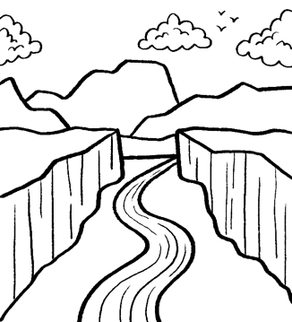  4 | 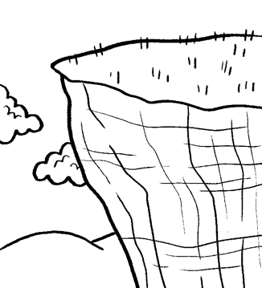 | 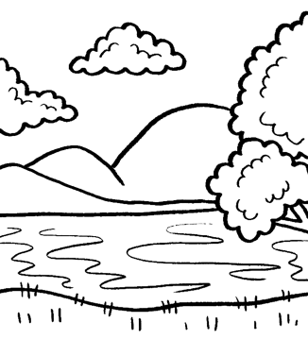 | 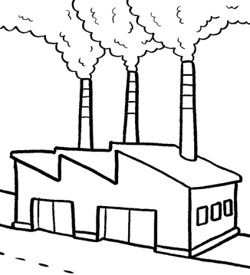
 | 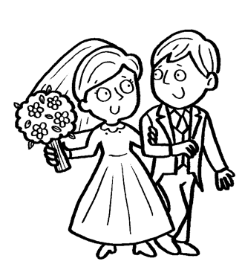  5 | 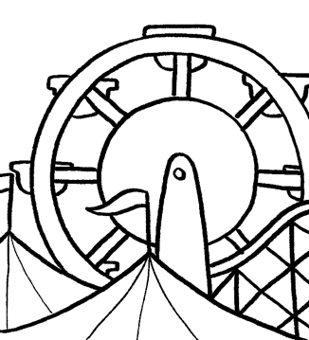 | 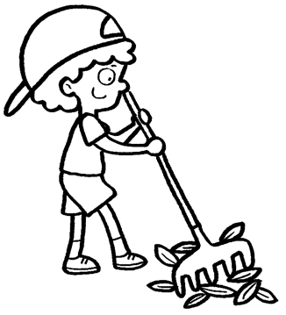 | 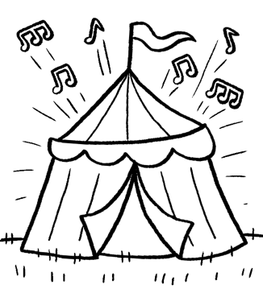

Listen and check the box. 6
1
1 What did Natalie do last Saturday?
 | 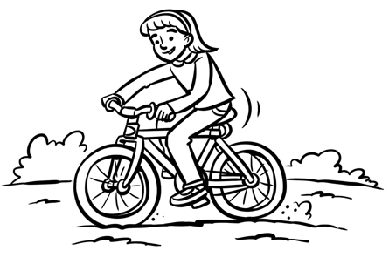  A | 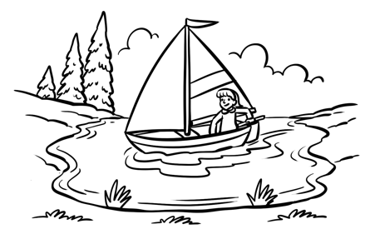  C  B | 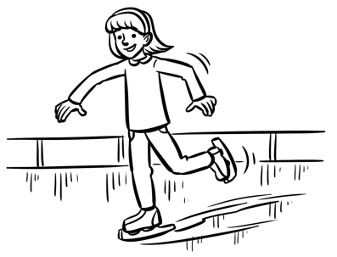
2 What did Natalie see?
 | 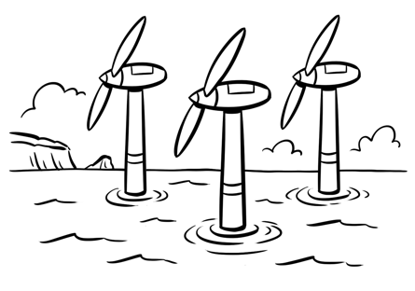  A | 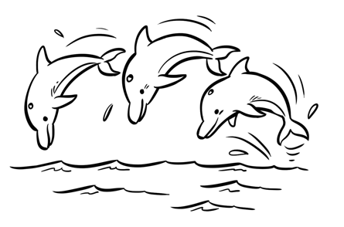  B | 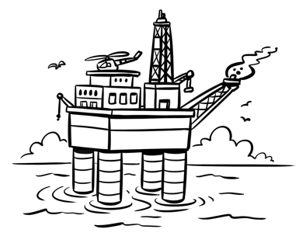  C
3 What did Natalie’s brother do?
 | 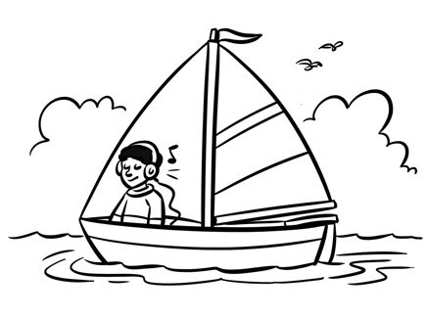  A | 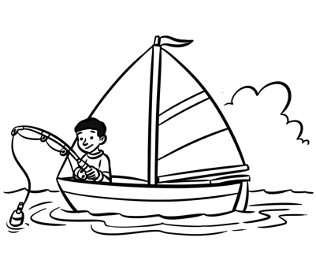  B | 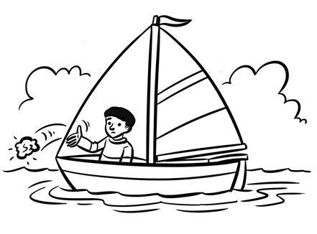  C
4 What animals did they see?
A
 | 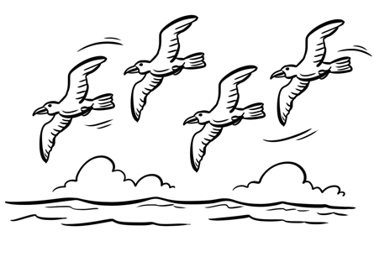 | 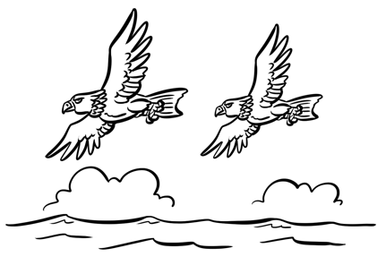  C | 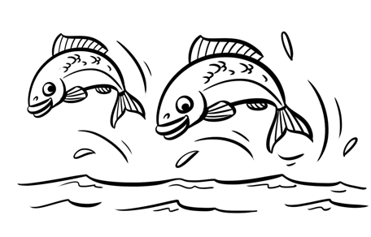  B
5 What time did they finish the activity?
 | 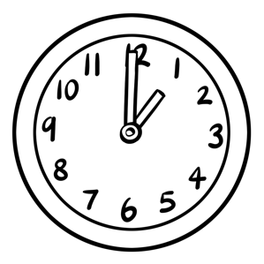  A | 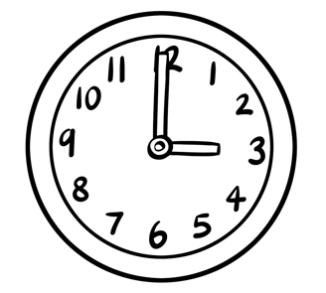  C | 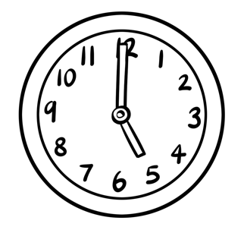  B

Look at the picture and read the story. Write some words
to complete the sentences about the story. You can use
one, two, or three words.
2
A
A Sick Boy
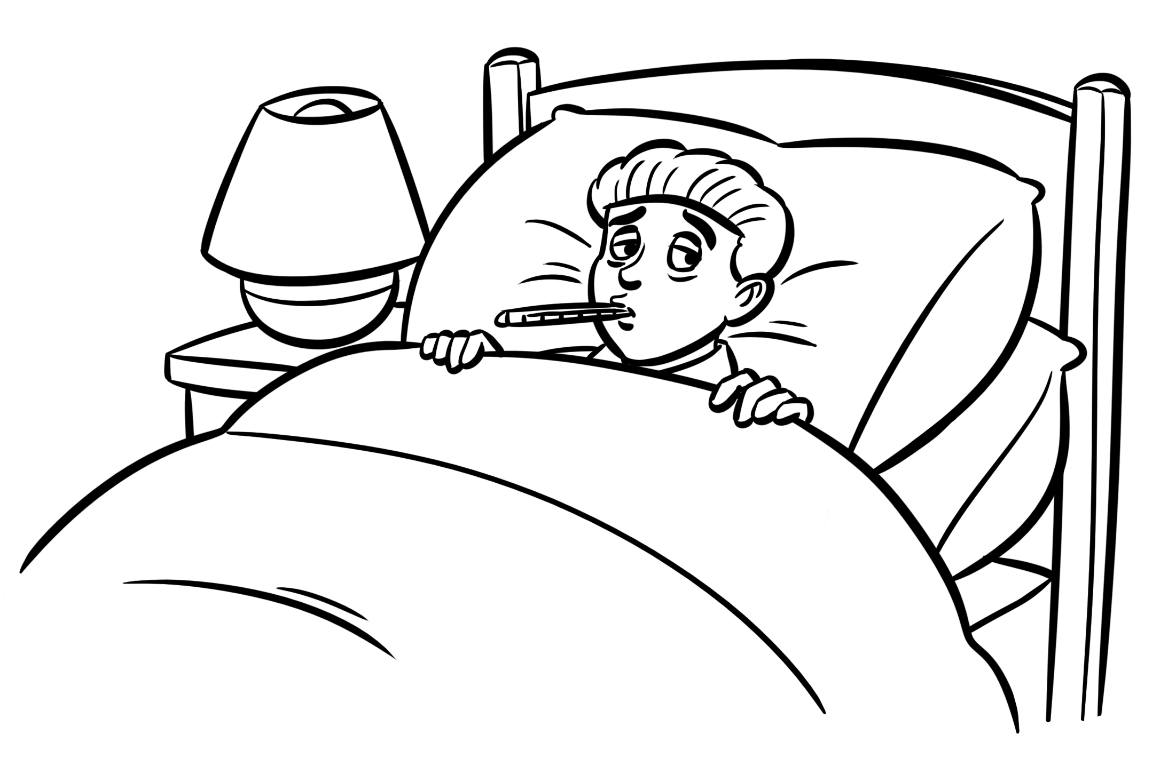
Josh was sick yesterday. He had a fever and an earache. His dad looked after him and he didn’t go to school. In the afternoon his friends came to visit. They brought him fruit and comics. He drank a lot of water and started to feel better. He has a test today so Josh wants to go to school. He wakes up in the morning and gets out of bed. He feels great! He tells his parents he can go to school. He takes his comics with him and reads them on the school bus. At school he takes the test and gets an amazing test score!
1 Josh was _______________ yesterday.
2 He had a fever and _______________.
3 His friends brought him _______________.
4 He reads on the _______________.
5 Josh takes a _______________ today.
Veronica is talking to her friend Maria. What does Maria say?
Read the conversation and choose the best answer.
Write a letter (A–H) for each answer.
3
1 Veronica: Where are you going after school? Maria: _____
2 Veronica: Who are you going with? Maria: _____
3 Veronica: What are you going to do? Maria: _____
4 Veronica: What time are you going home? Maria: _____
5 Veronica: Do you want to watch a movie later? Maria: _____
A I’m not going there.  B Yes, that will be fun.  C We’re going to play soccer.  D I like tennis. |  |  | E At 5 o’clock.  F I’m going with Jenny.  G I’m going to the park.  H Yes, I will.

Read the story. Write the correct words next to numbers 1–5.
4
My name’s Holly. I play the flute in my school orchestra. Last weekend
we played a (1) _______________ for lots of people. We played in the park. First we had lunch. We had a (2) _______________ with our
parents and friends. We ate sandwiches and (3) _______________.
Then we sat on chairs and played music for everyone. My friend Sally plays the (4) _______________. She had a solo. She played really well. After the concert my (5) _______________ talked to my mom. She said that I was really good at music. She wants me to have lessons with a famous musician! My mom and dad were really pleased, and I’m happy.
It was a great day.
 | 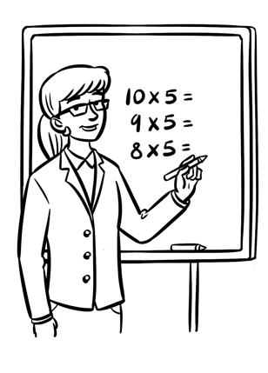 | 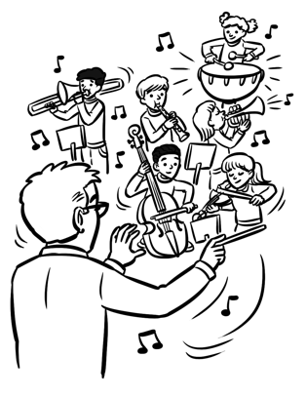 | 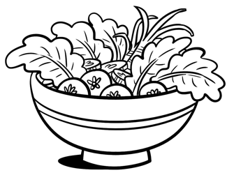 | 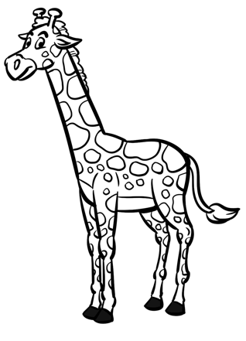
 | teacher | concert | salad | giraffe
 | 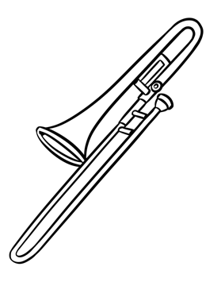 | 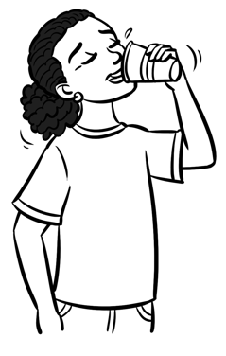 | 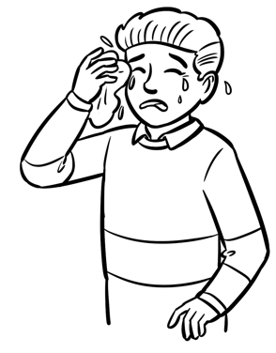 | 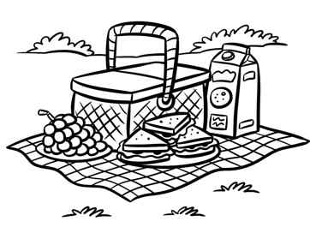
 | trombone | drink | cry | picnic

Find the differences.
5
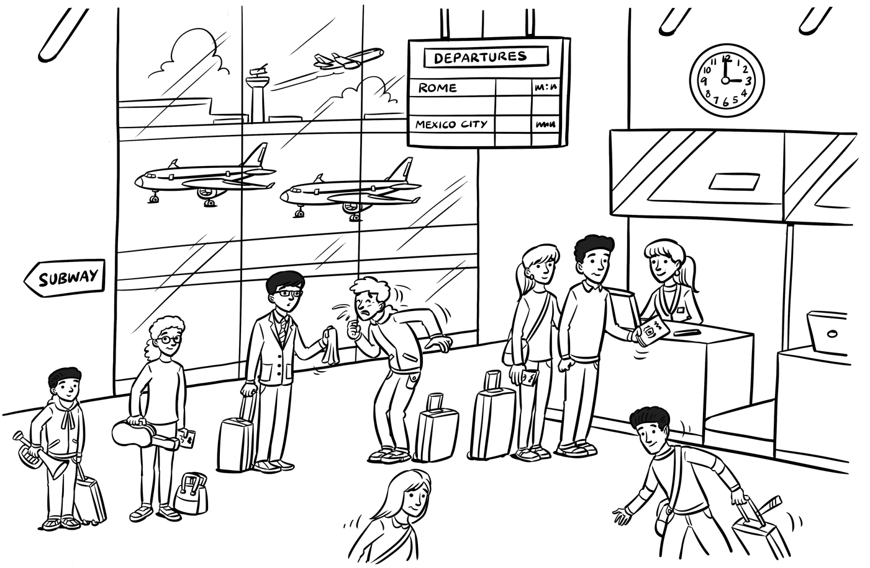
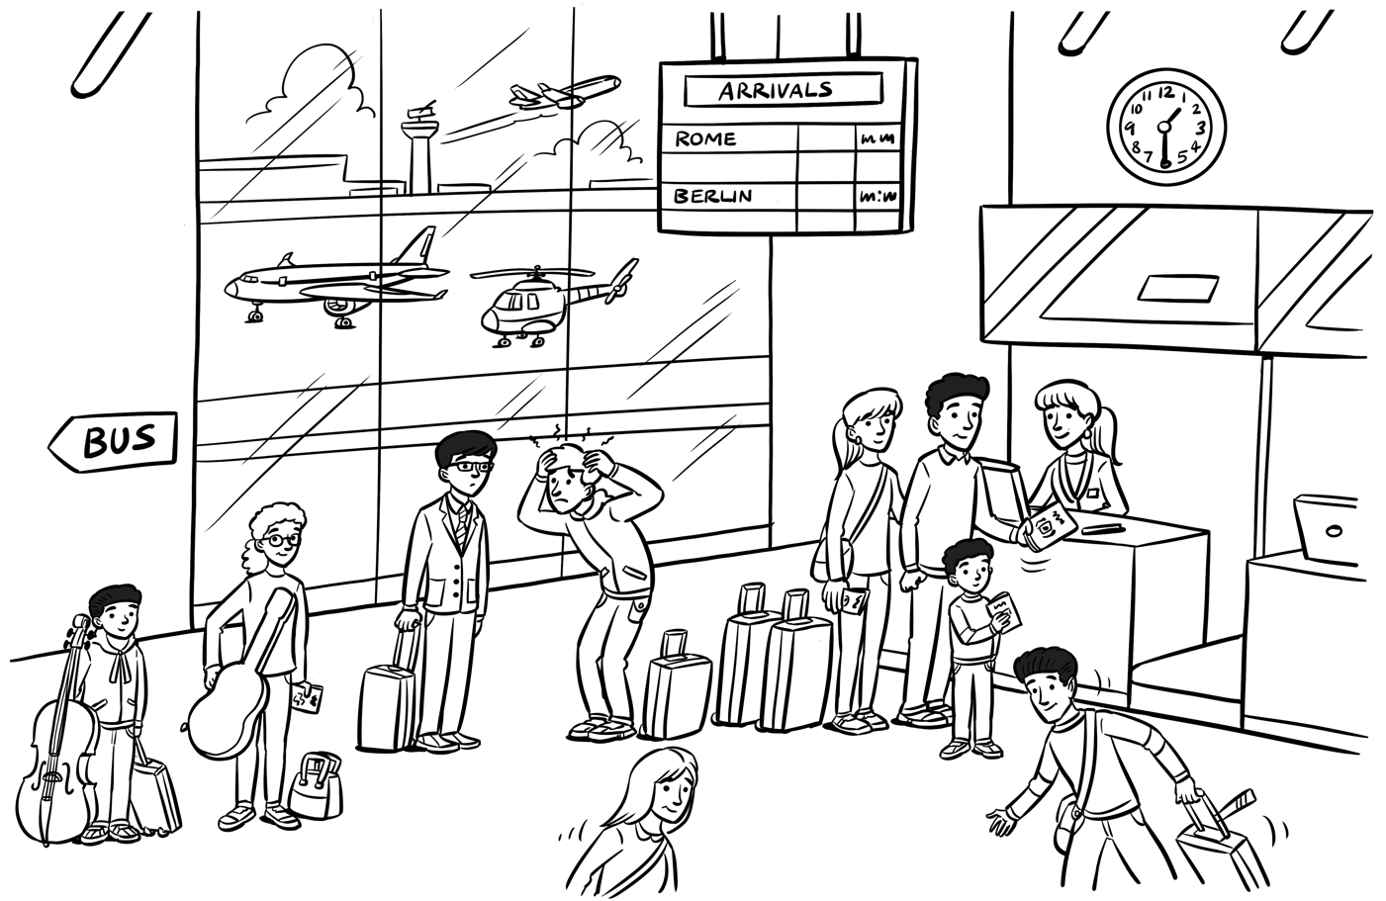

Listen and write. 7
1
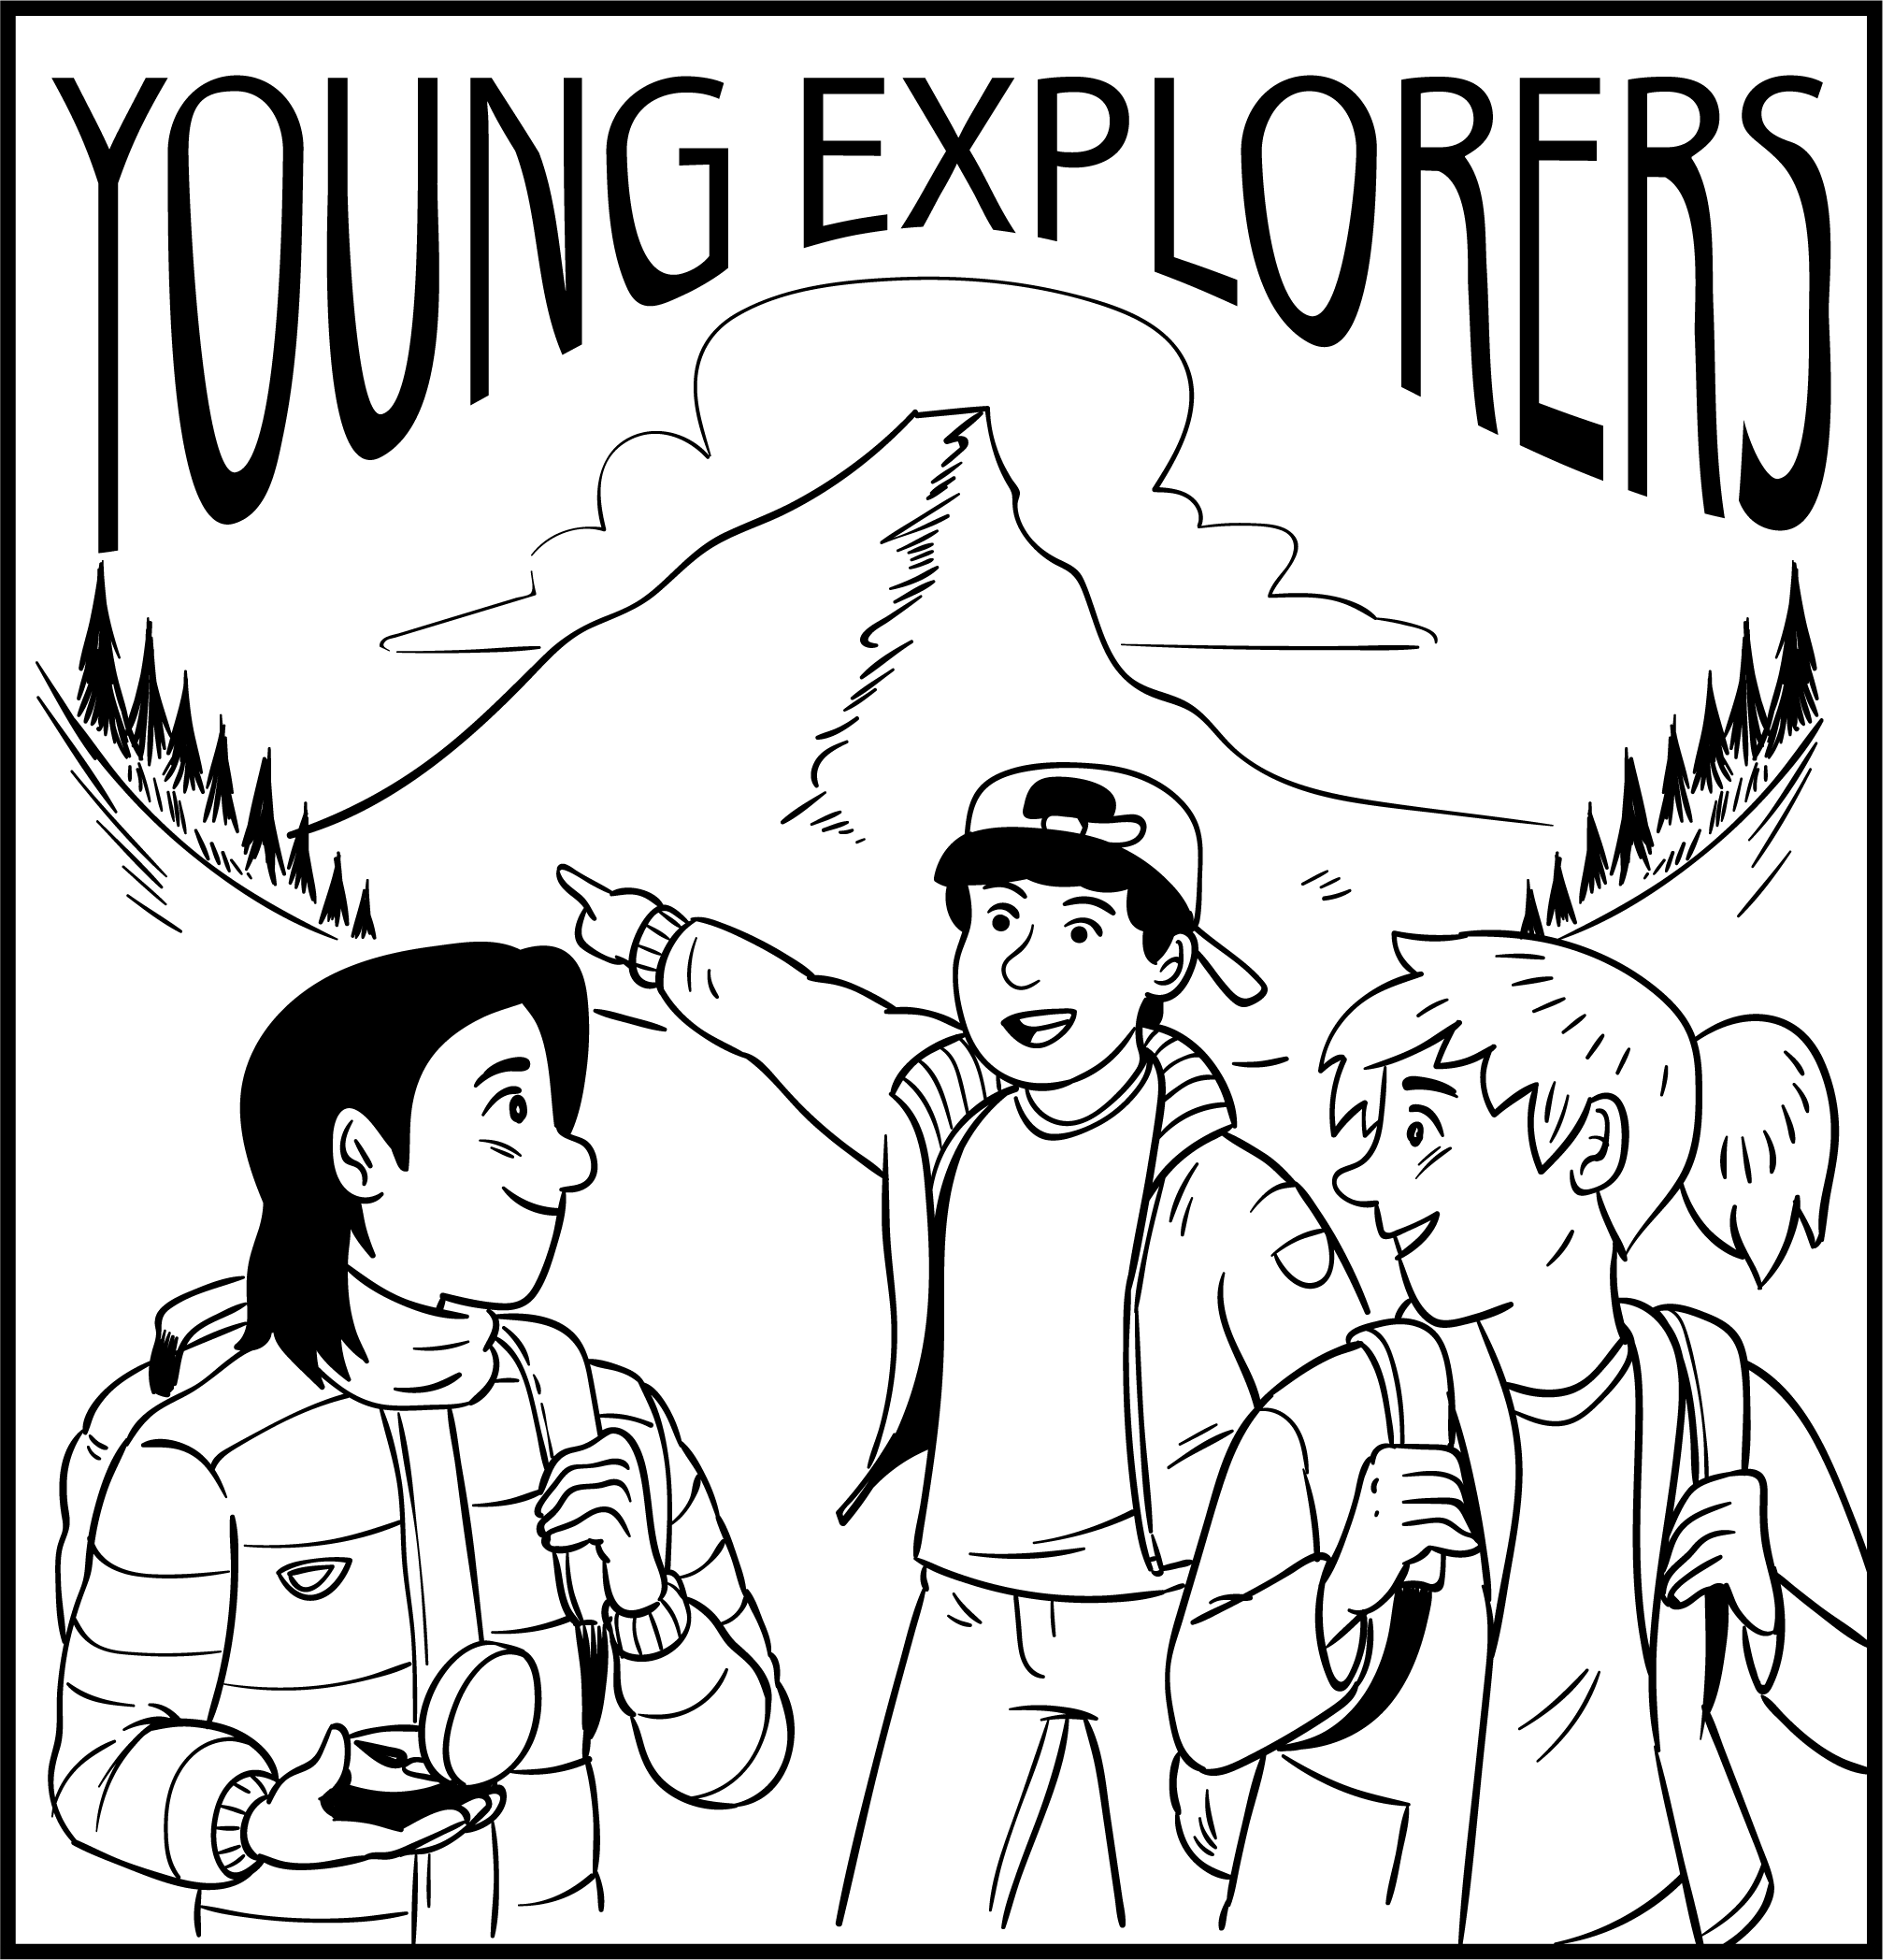
1 What day? _______________ after school.
2 Where is it? _______________ the school.
3 Where will they go on the special trip? _____________________________
4 How long? _______________ hours.
5 How much? _______________

Look and read. Choose the correct words and write them
on the lines.
2
A
door knob wheel coast island gardener
1 Land that is surrounded by water. _______________
2 The area of land where it meets the ocean. _______________
3 This is something that helps a lot of transport to move. _______________
4 You turn this to open a door. _______________
5 A person who works with plants. _______________
Read the text. Choose the correct words and write them
on the lines.
3
Bicycles
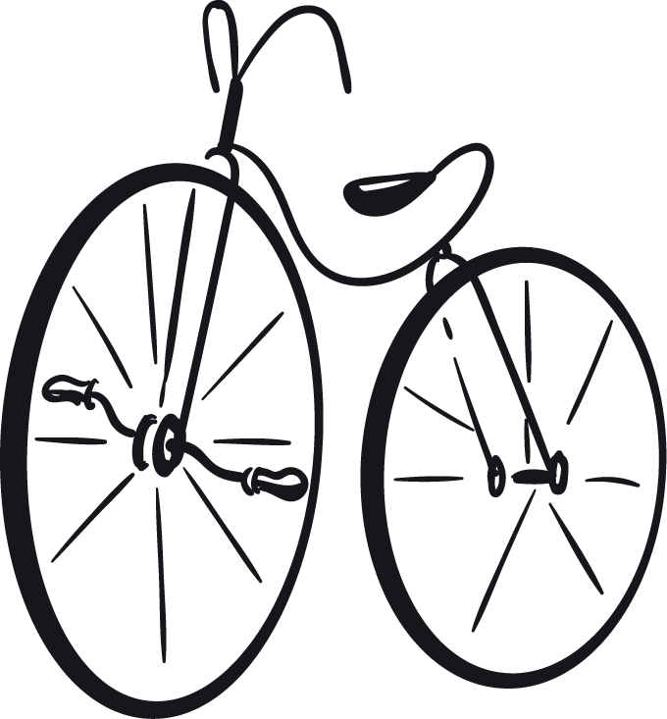
1
The bicycle _______________ invented in 1817 in Germany. It was _______________ of wood and was very big and heavy. People didn’t _______________ the bicycles. They sat on them, but they pushed them along with their feet. It wasn’t until 1863 that pedals were added to bicycles. People _______________ then take their feet off the ground. The front wheel was much _______________ than now and the back wheel was smaller. But it helped people move around more easily and quickly and changed transport forever.
4
5
3
2
1 is are was
2 do make made
3 ride walk run
4 could can should
5 big bigger biggest

Look at the three pictures. Write about this story.
Write 20 or more words.
4
 |  | 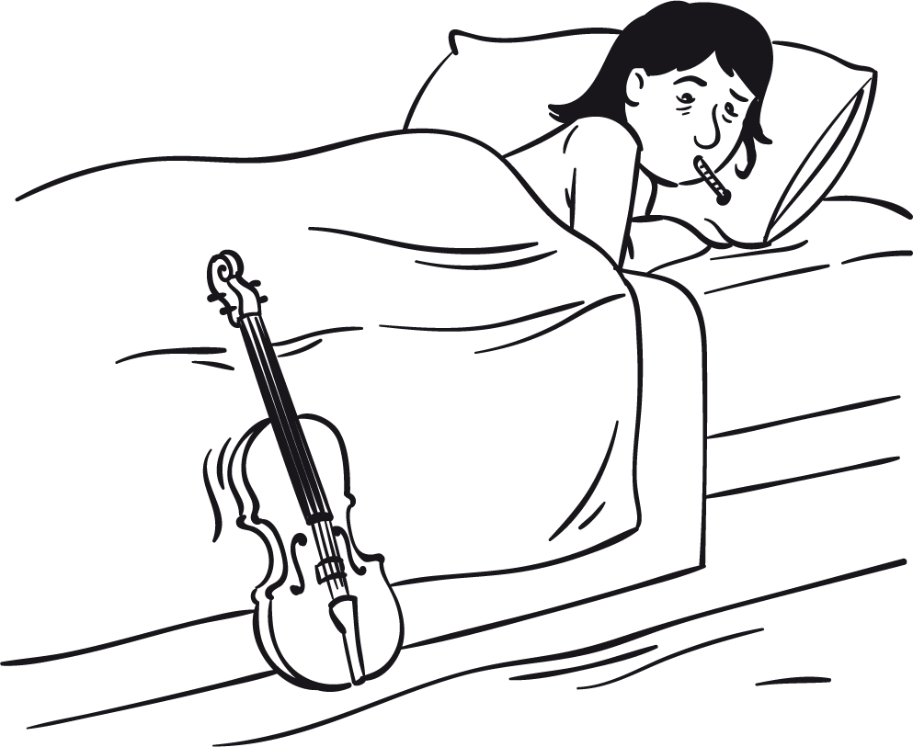 |  |  | 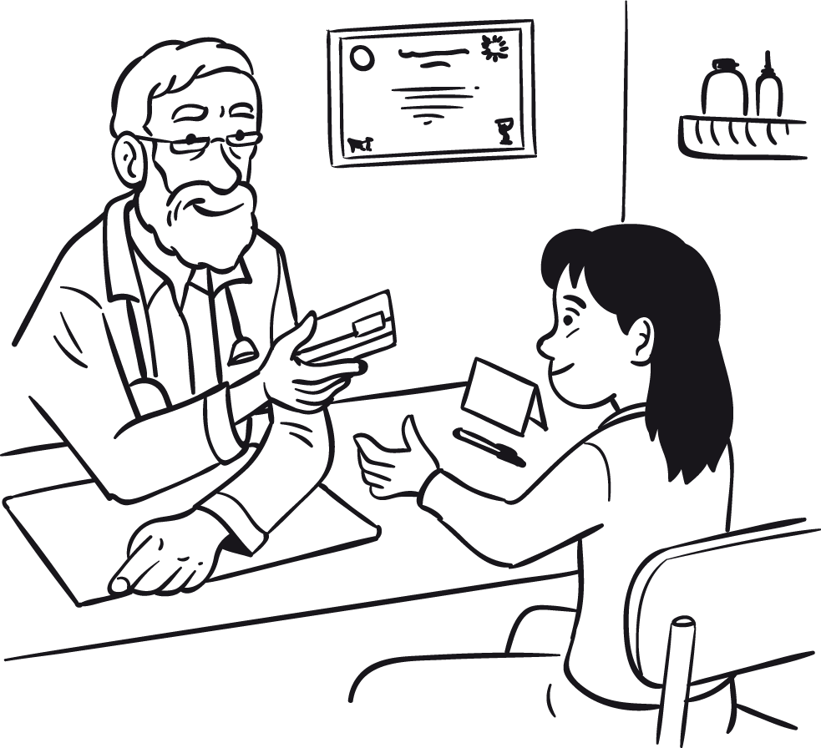
 |  |  | 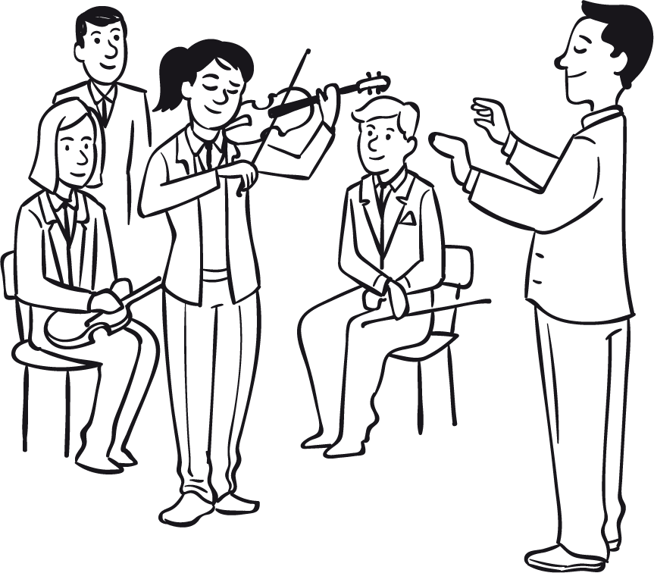
 | Try to use these words in your story.
 | violin sick doctor medicine concert healthy
_________________________________________________________________
_________________________________________________________________
_________________________________________________________________
_________________________________________________________________
_________________________________________________________________
_________________________________________________________________

Tell the story.
5
An Interesting Trip
Sam
 | 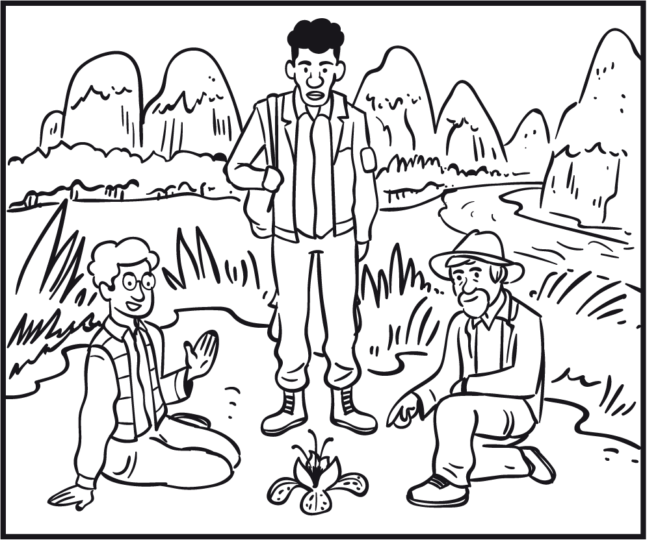  Mike | 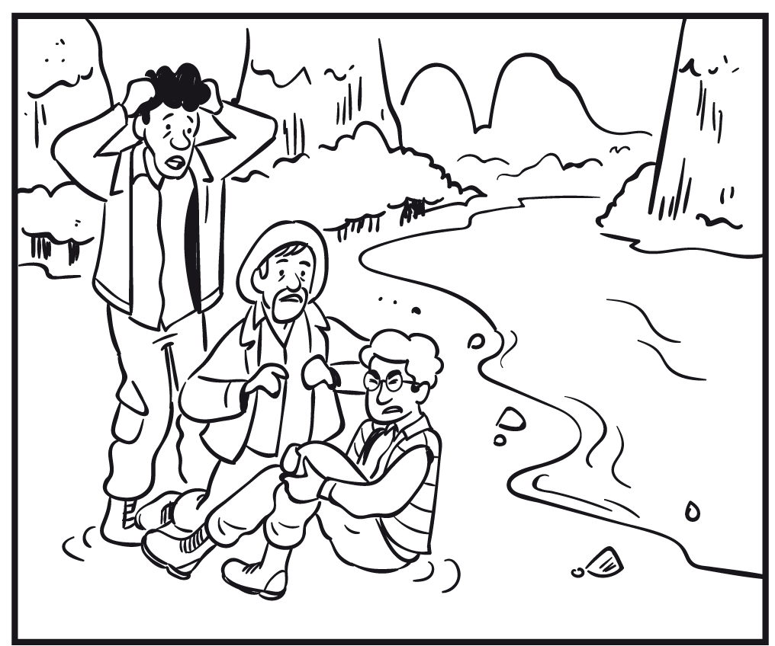  Charlie
 | 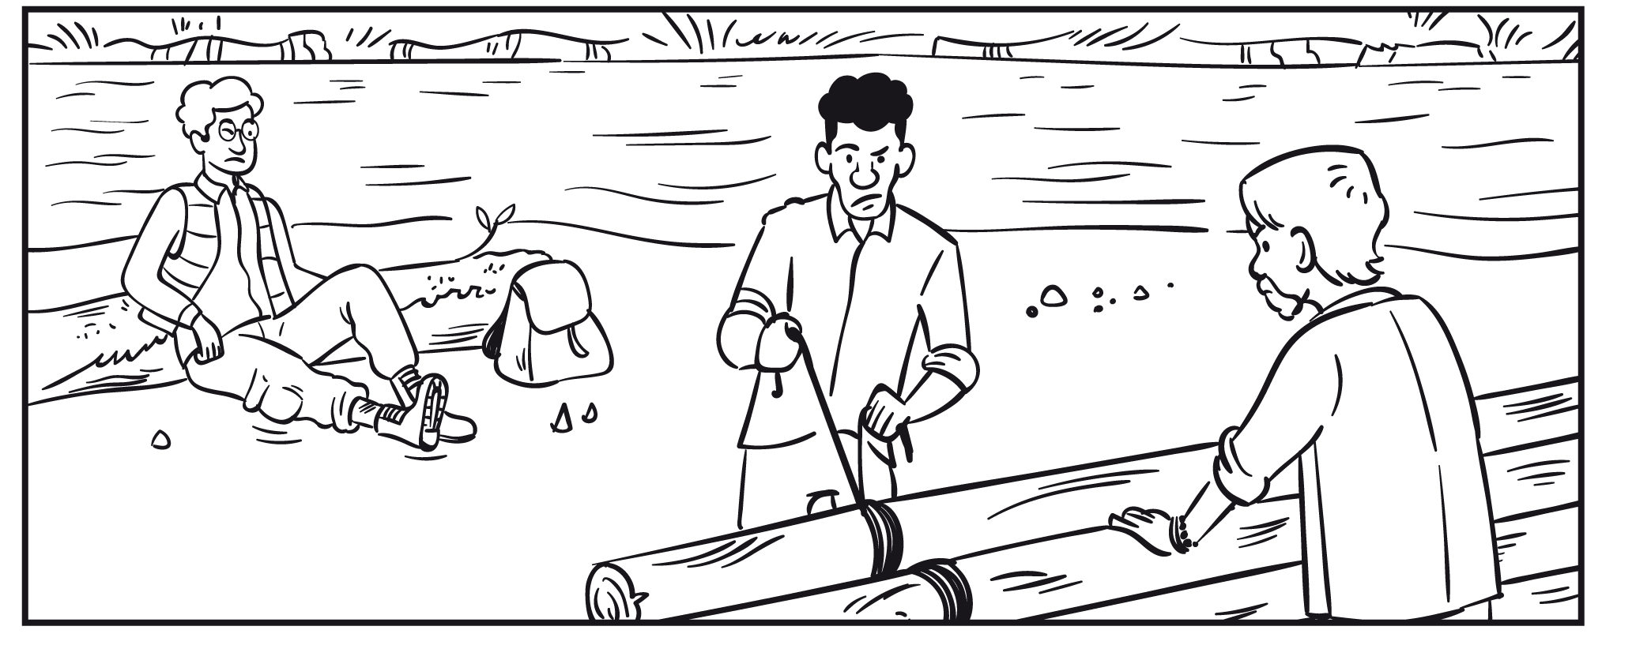
 | 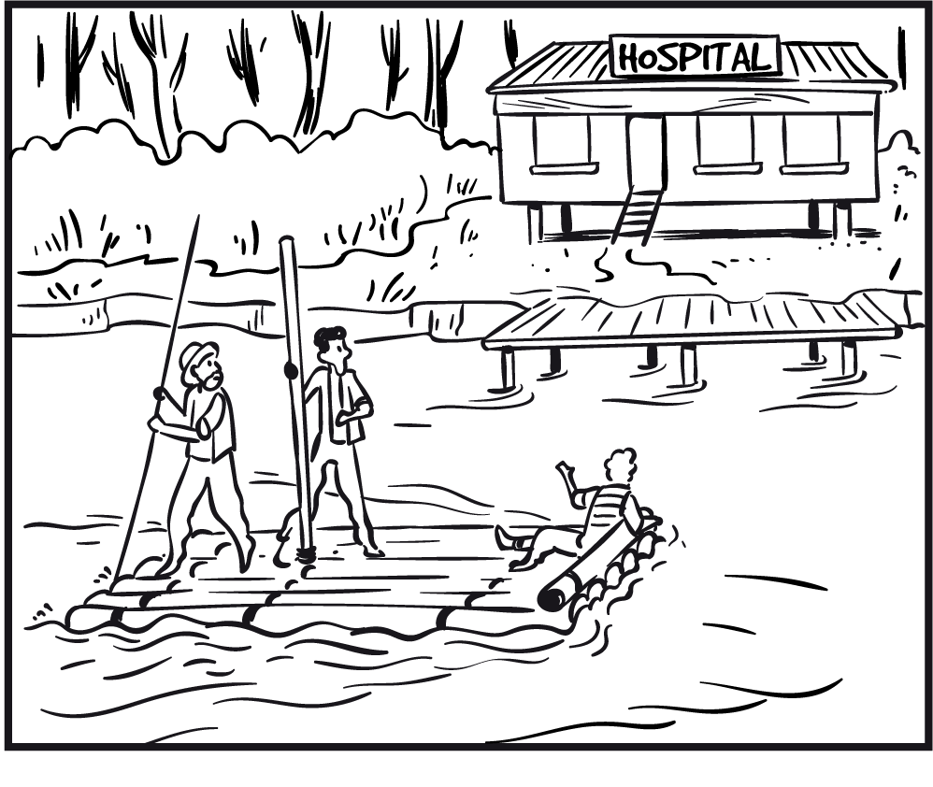 | 