El Aparato Locomotor

[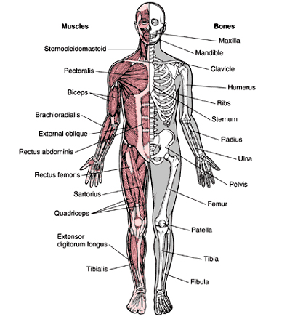](https://wikisabio.com/el-aparato-locomotor/)