Listen and write.  5
1
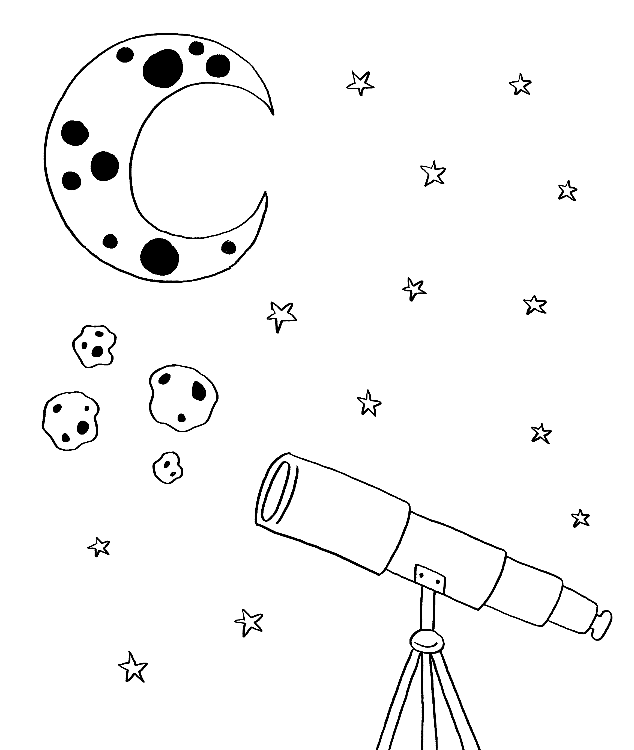
1 Name of place: _______________ Observatory.
2 Opening hours: 5pm – _______________.
3 Address: 14 _______________ Street.
4 Interesting things for children: asteroids and _______________.
5 Bring: a coat and _______________

Look and read. Choose the correct words and write them
on the lines.
2
leopard telescope butter sugar soldiers

1 This is something you look through to see the stars. _______________
2 This is something sweet you put in cookies and cakes. _______________
3 This is a big cat that lives in the jungle. _______________
4 This is something you put on bread. _______________
5 These are people that are part of an army. _______________
Read the text. Choose the correct words and write them
on the lines.
3
Dinosaurs
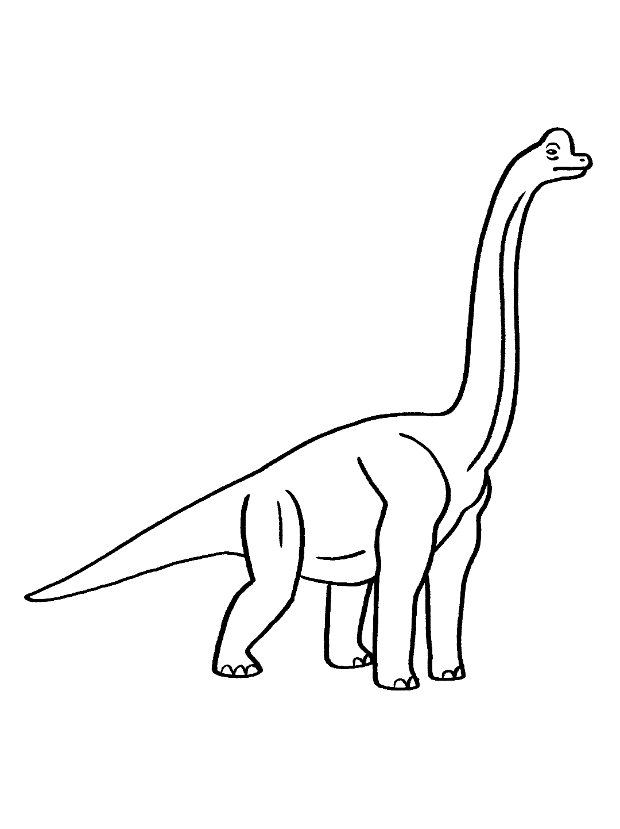
1
A long time _a______________, dinosaurs lived on the Earth. There were many different types of dinosaurs. The climate _______________ very warm and comfortable. Some animals were similar to animals that we _______________ today, but they were often bigger. Some dinosaurs lived on the ground, others in water, and large bird-like dinosaurs _______________ in the skies. Some dinosaurs ate plants and others ate meat. Scientists think that _______________ the Earth got colder, the dinosaurs couldn’t find enough to eat and after a while they disappeared.
2
3
4
5
3
4
5
4
5
1 ago past in
2 can was is
3 see seen saw
4 grow fly flew
5 that when what

Look at the three pictures. Write about this story.
Write 20 or more words.
4
 |  | 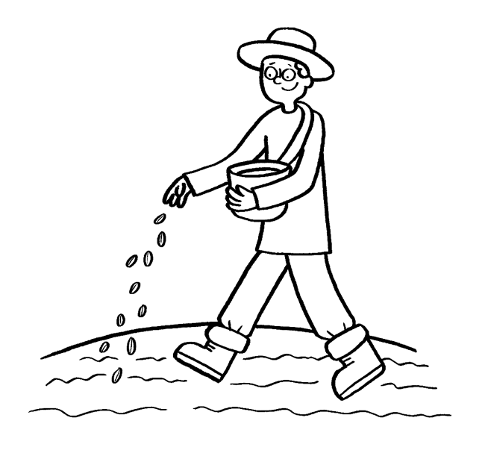 |  |  | 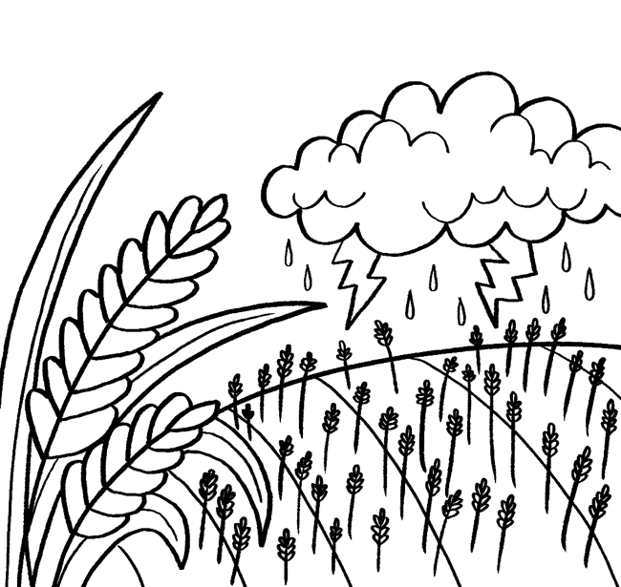
 |  |  | 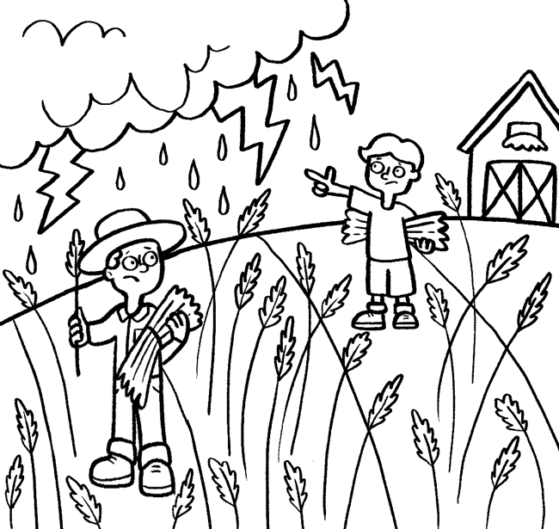
Try to use these words in your story.
wheat farmer storm plantation spoil gather

_________________________________________________________________
_________________________________________________________________
_________________________________________________________________
_________________________________________________________________
_________________________________________________________________
_________________________________________________________________

Find the differences.
5
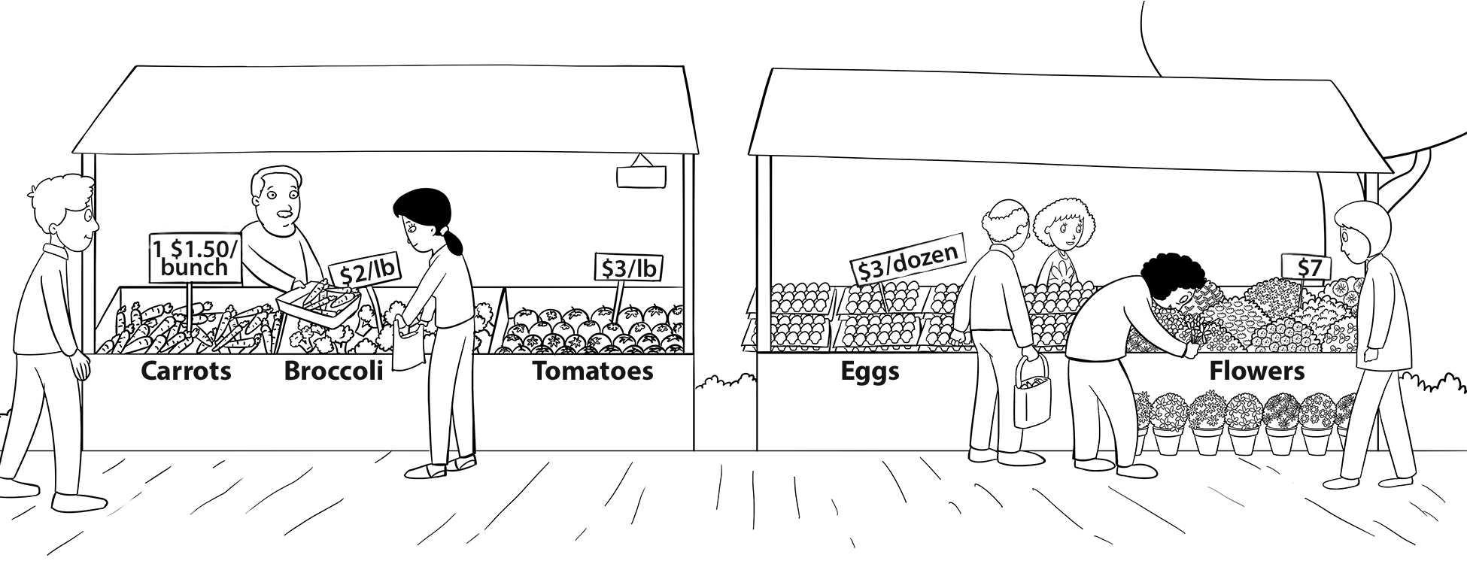
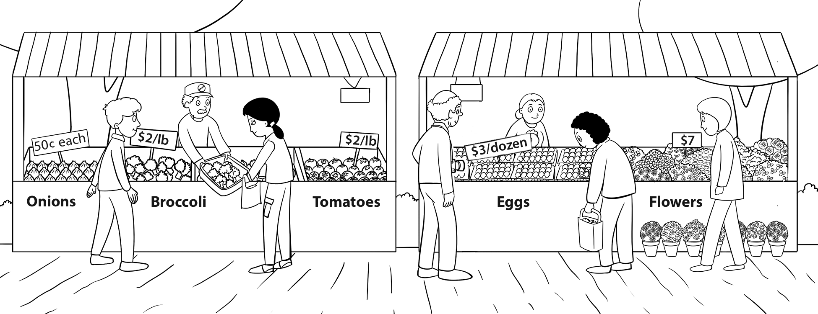
/ 30

Listen and check the box. 6
1
1 Where does Kim live?
 |  |   A | 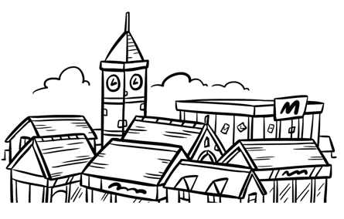  B | 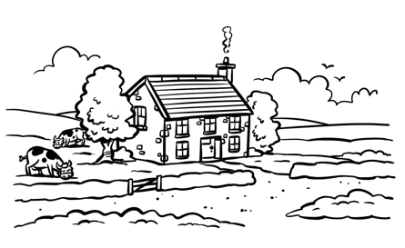  C
2 How does Kim travel to her piano lesson?
 |  | 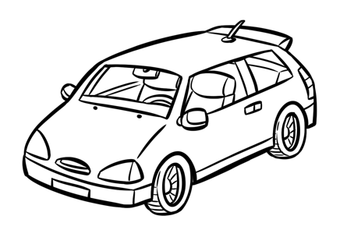  A | 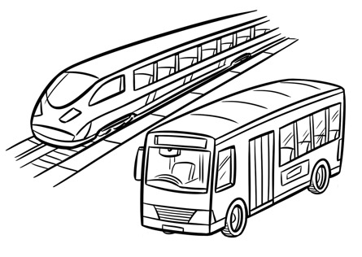  B | 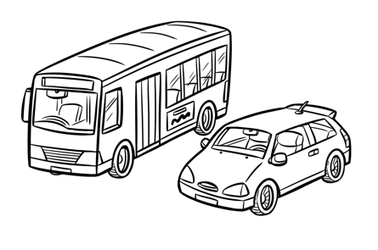  C
3 What time does Kim leave home?
 |  | 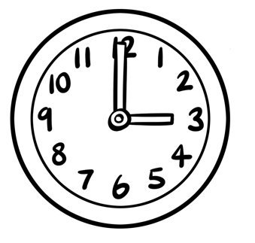  A | 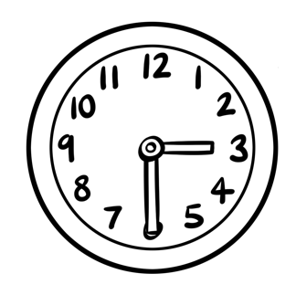  B | 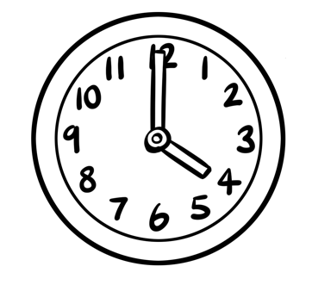  C
4 How will Kim travel back to the city?
A
 |  | 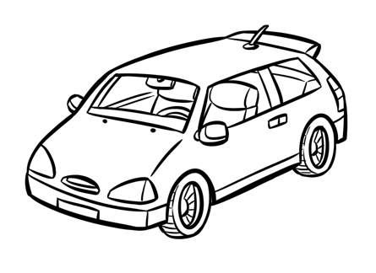 | 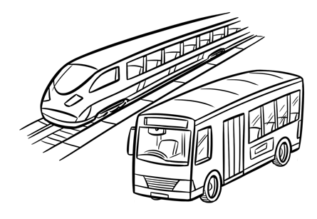  C | 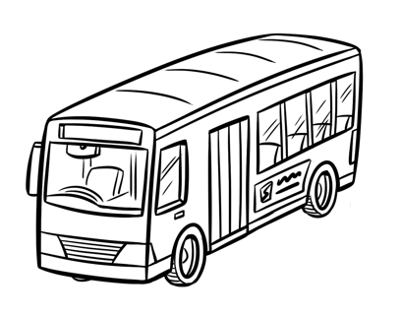  B
5 What will Kim do this evening?
 |  | 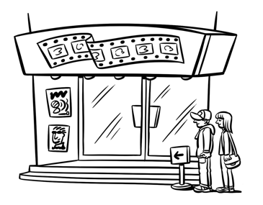  A | 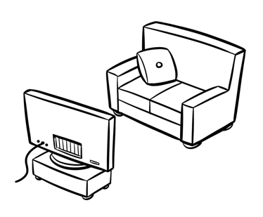  C | 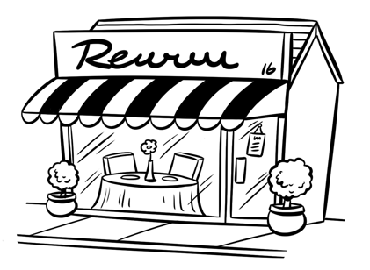  B

Sophia is talking to her friend Molly. What does Molly say? Read the conversation and choose the best answer. Write a letter (a–h) for each answer.
2
A
1 Sophia: Hi, Molly. How are you? Molly: _______________
2 Sophia: Oh, no. What’s wrong? Molly: _______________
3 Sophia: Why aren’t you at home in bed? Molly: _______________
4 Sophia: Are you going to the party tomorrow? Molly: _______________
5 Sophia: I hope you feel better soon. Molly: _______________
a I’m playing tennis.  b I’m going to the doctor.  c He’s sick.  d Not so good. I’m ill. |  | e No, I don’t.  f I have the flu.  g Thanks. Me too.  h No. I’m staying in bed tomorrow.
Look at the picture and read the story. Write some words to
complete the sentences about the story. You can use one to
three words.
3
The Art Class
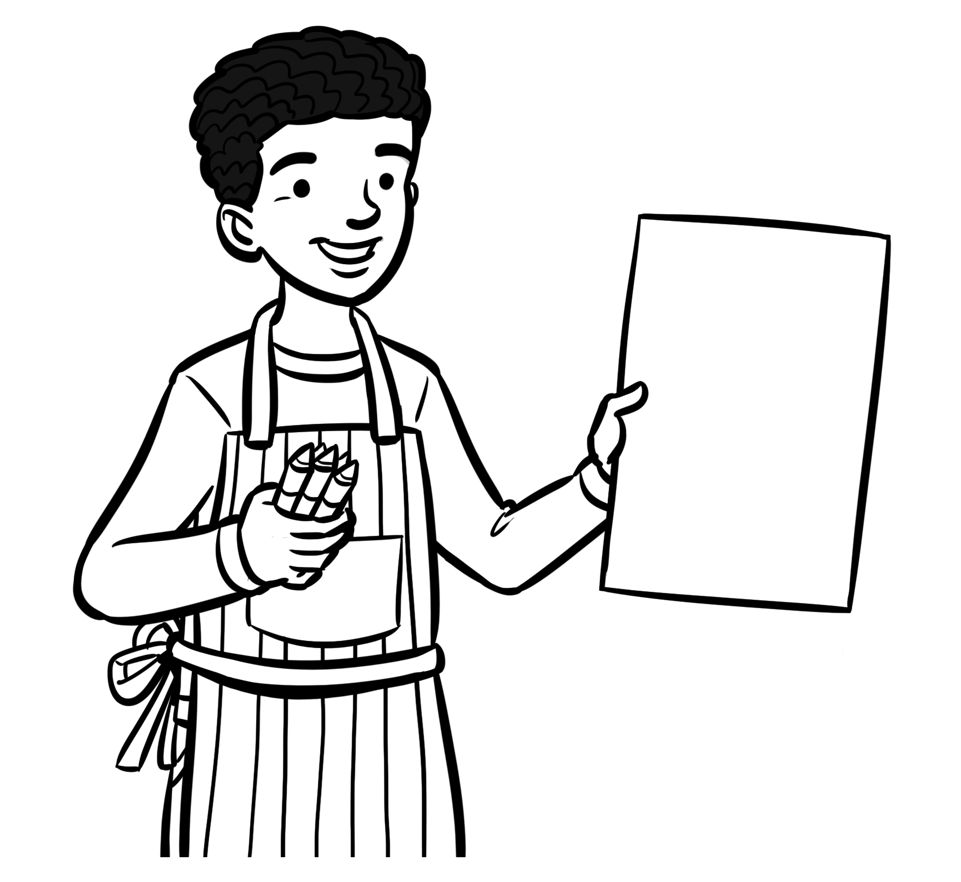
Hello! I’m Alex. I had a very busy morning in art class. First, we sketched
a landscape using pastels. Our teacher gave us a photo to copy. My friend, Simon, drew a really fantastic picture. He is good at drawing trees. Then, we made a collage of our house using different colored shapes. It was very difficult, but I think you can see my house in the picture. My mom put it up on the refrigerator when I arrived home. My sister came home later and she said she couldn’t see a house
at all. She didn’t like my picture! But I had a really amazing day.
3
4
5
4
5
1 Alex went to _______________ this morning.
2 Alex sketched his landscape using _______________.
3 He made a collage using _______________.
4 You _______________ his house in the picture.
5 Alex’s sister _______________ his picture.

Read the postcard and write the missing words. Write one word on each line.
4
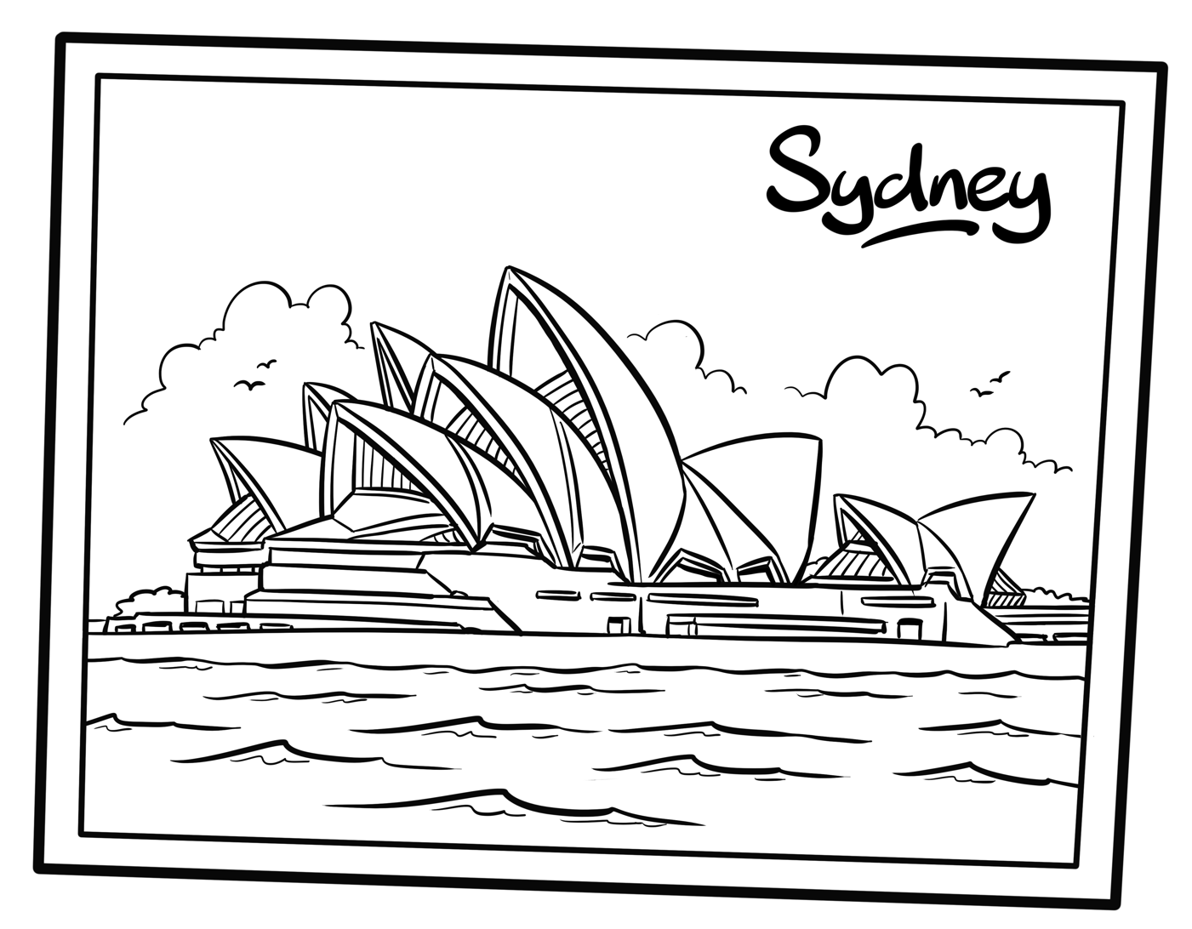
Dear Oliver,
I (1) _______________ having a wonderful time in Sydney at the moment. It’s very different from Colorado. The city is surrounded by water and it’s very hot and sunny. This morning we (2) _______________ the Sydney Opera House. It’s huge! It’s in the center of the city and the roof looks like a wave. We’re (3) _______________ to the Sydney Harbour Bridge this afternoon. Tomorrow we’re going to visit (4) _______________ area called The Rocks. This is a big place that has lots of shops and restaurants in very old buildings. We will be here for another three days and then (5) _______________ come home.
See you soon!
Phil

Look and find the different ones.
1
5
 | 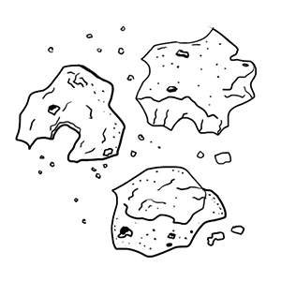 |  | 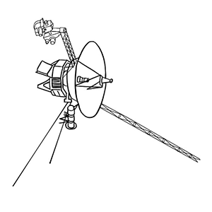 | 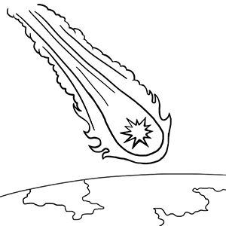
 | 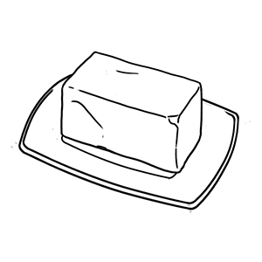  2 | 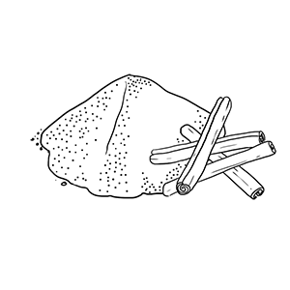 | 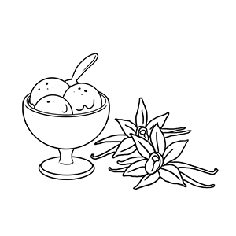 | 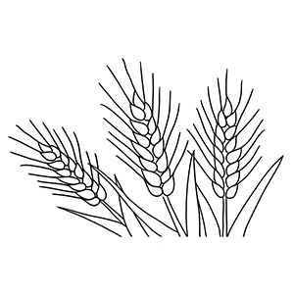
 | 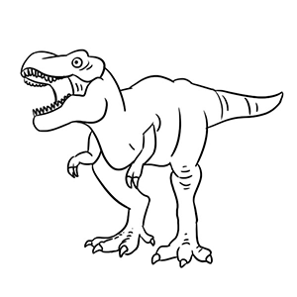  3 |  | 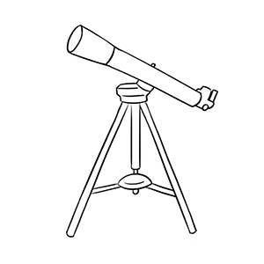 | 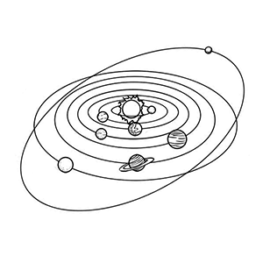
 | 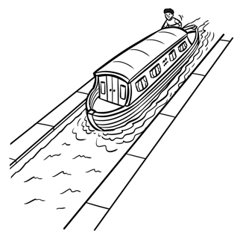  4 | 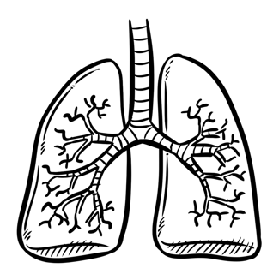 | 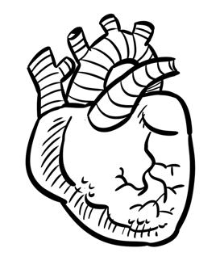 | 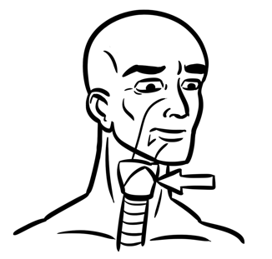
 | 5
 | 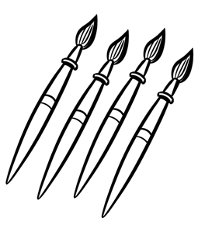 | 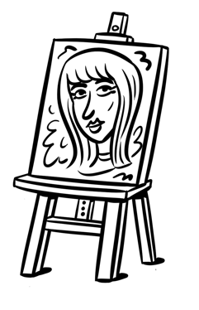 | 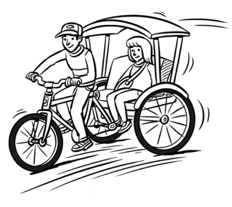 | 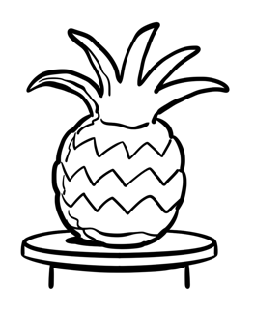

Where do Beth and her family work? Listen and write a letter
in each box. 7
1
 |   1 | Beth  A | 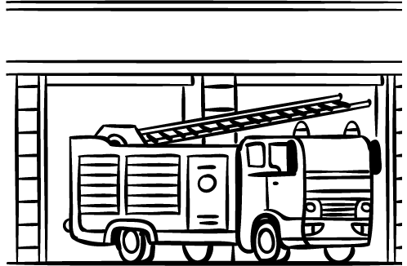 | 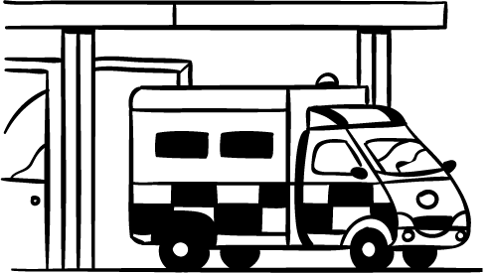  B
 | 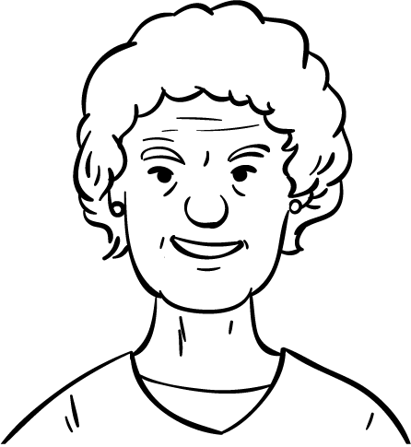  2 | Beth’s  mother  C | 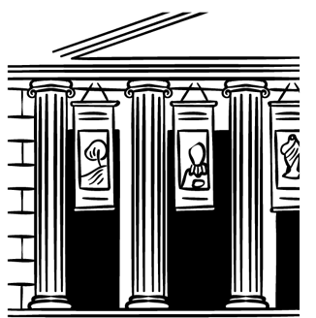 |   D
 | 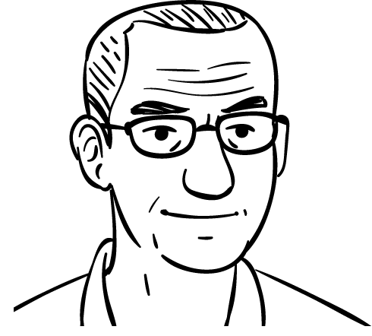  3 | Beth’s  father | 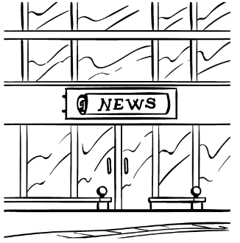  G  E | 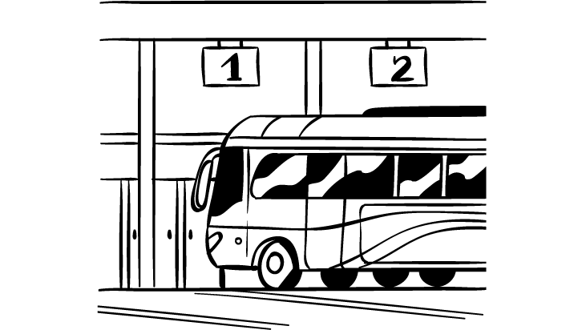  F
 | 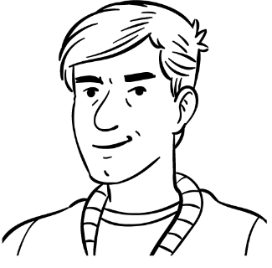  4 | Cousin  Steven | 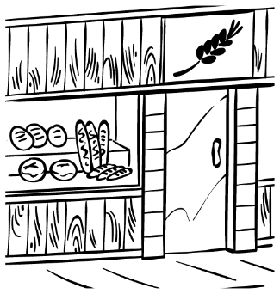 | 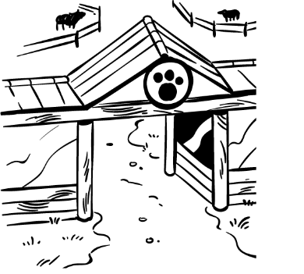  H
 | 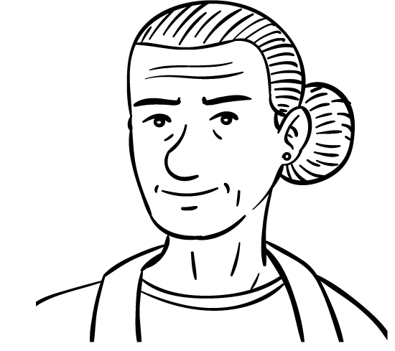  5 | Aunt Mary | 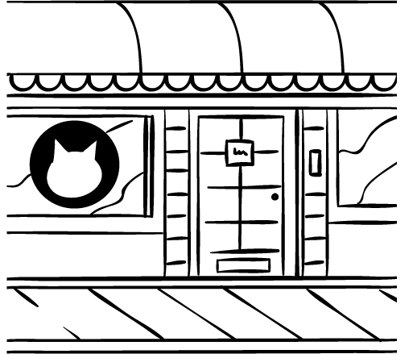  J  I | 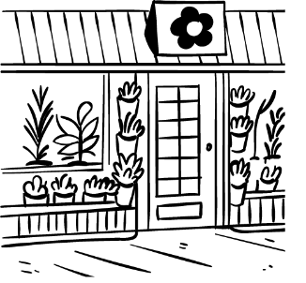

Read the text. Choose the correct words and write them
on the lines.
2
A
Rainforests
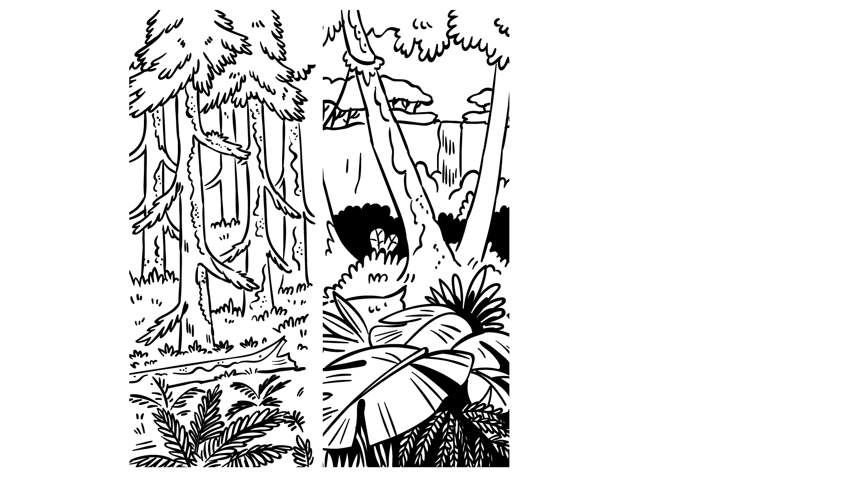
1
Tropical rainforests _______________ humid and hot, but temperate rainforests are cool. Temperate rainforests are _______________ in areas with four separate seasons. Temperate rainforests often _______________ trees that are very old, but tropical rainforests have trees that are much younger. Tropical rainforests have hundreds of different species _______________ trees and flowers, _______________ temperate rainforests have fewer species. Animals live in both types of forests.
5
2
3
4
5
1 is are was
2 put located made
3 have give do
4 of on about
5 the and but
Look and read. Choose the correct words and write them on the lines.
3
cactus flood newspaper journalist sloth
1 This is something that happens when water levels
rise very quickly. _______________
2 This is a plant that grows in the desert and doesn’t
need much water. _______________
3 This is a person who interviews people for their job. _______________
4 This is something we read to find out about the news. _______________
5 This is a mammal that lives in the rainforest. _______________

Look at the three pictures. Write about this story.
Write 20 or more words.
4
 |  | 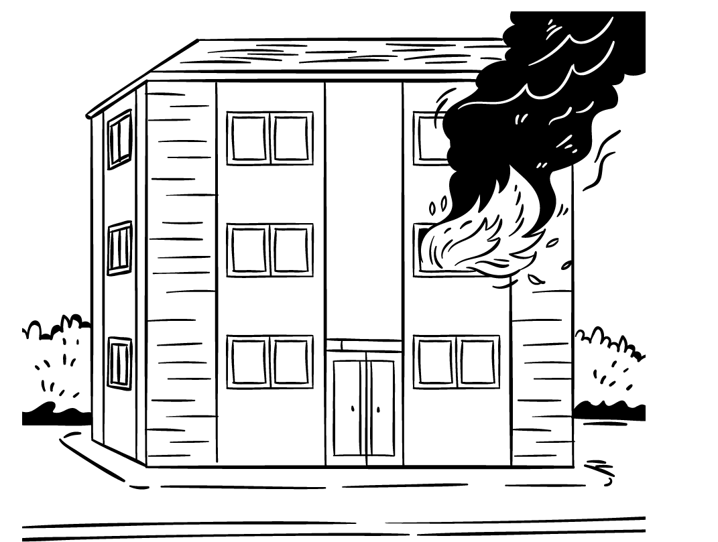 |  |  | 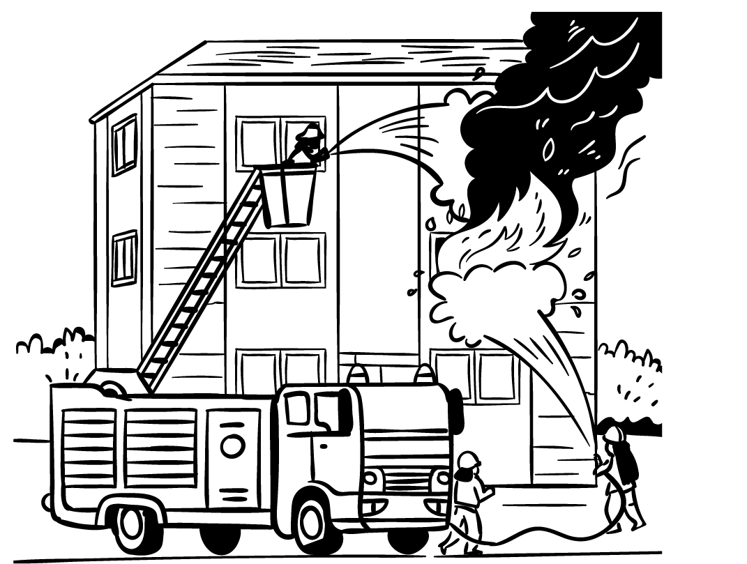
 |  |  | 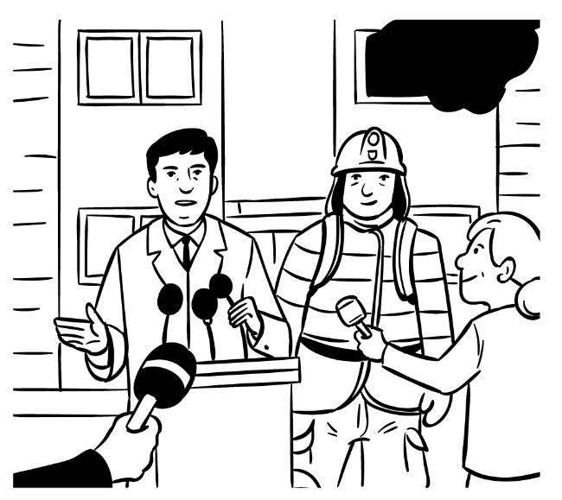
Try to use these words in your story.
fire apartment city firefighter safe news conference

_________________________________________________________________
_________________________________________________________________
_________________________________________________________________
_________________________________________________________________
_________________________________________________________________
_________________________________________________________________

Tell the story.
5
A Day at the Beach
Harry
Peter
 | 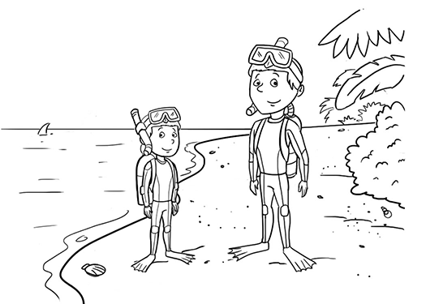 | 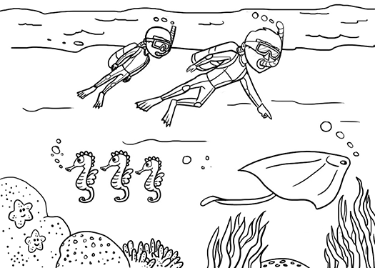
 | 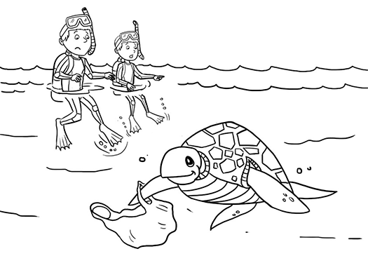
 | 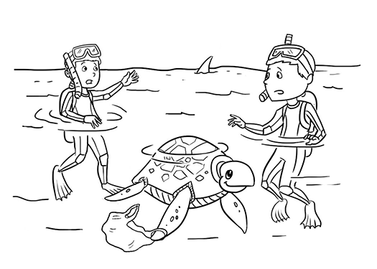 | 