Listen and choose the correct pictures.  5
1
1 What’s Sylvia going to do this afternoon?
 |  |  | 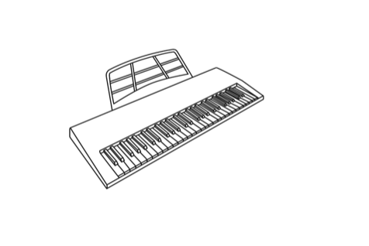 |  |  |  | 
 |  |  | A |  |  | B | C
2 What will Peter be able to use next year?
 |  |  |  |  |  |  | 
 |  | A |  |  | B |  | C
3 How long has Malcolm been studying French?
 |  |  |  |  |  |  | 
 |  | A |  |  | B |  | C
4 Why is Caroline going to the dentist?
 | 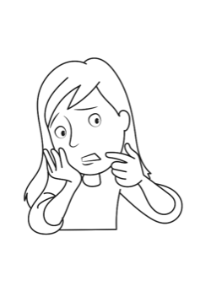 |  |  | 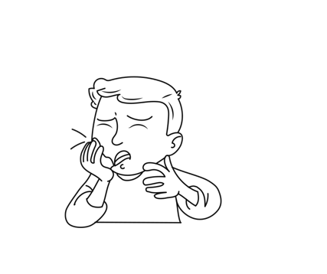 |  |  | 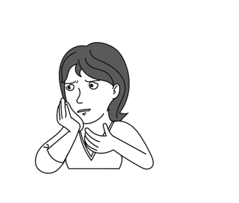
 | A |  |  | B |  |  | C
5 What will the weather be like tomorrow?
 |  |  |  |  |  |  | 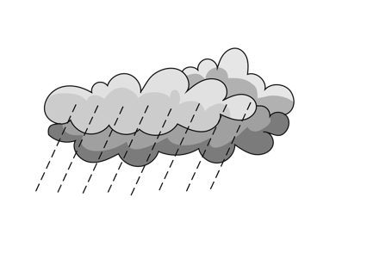
 | A |  |  | B |  |  | C

Read the text and circle the correct answers.
2
By Kia Borrell, Age 11
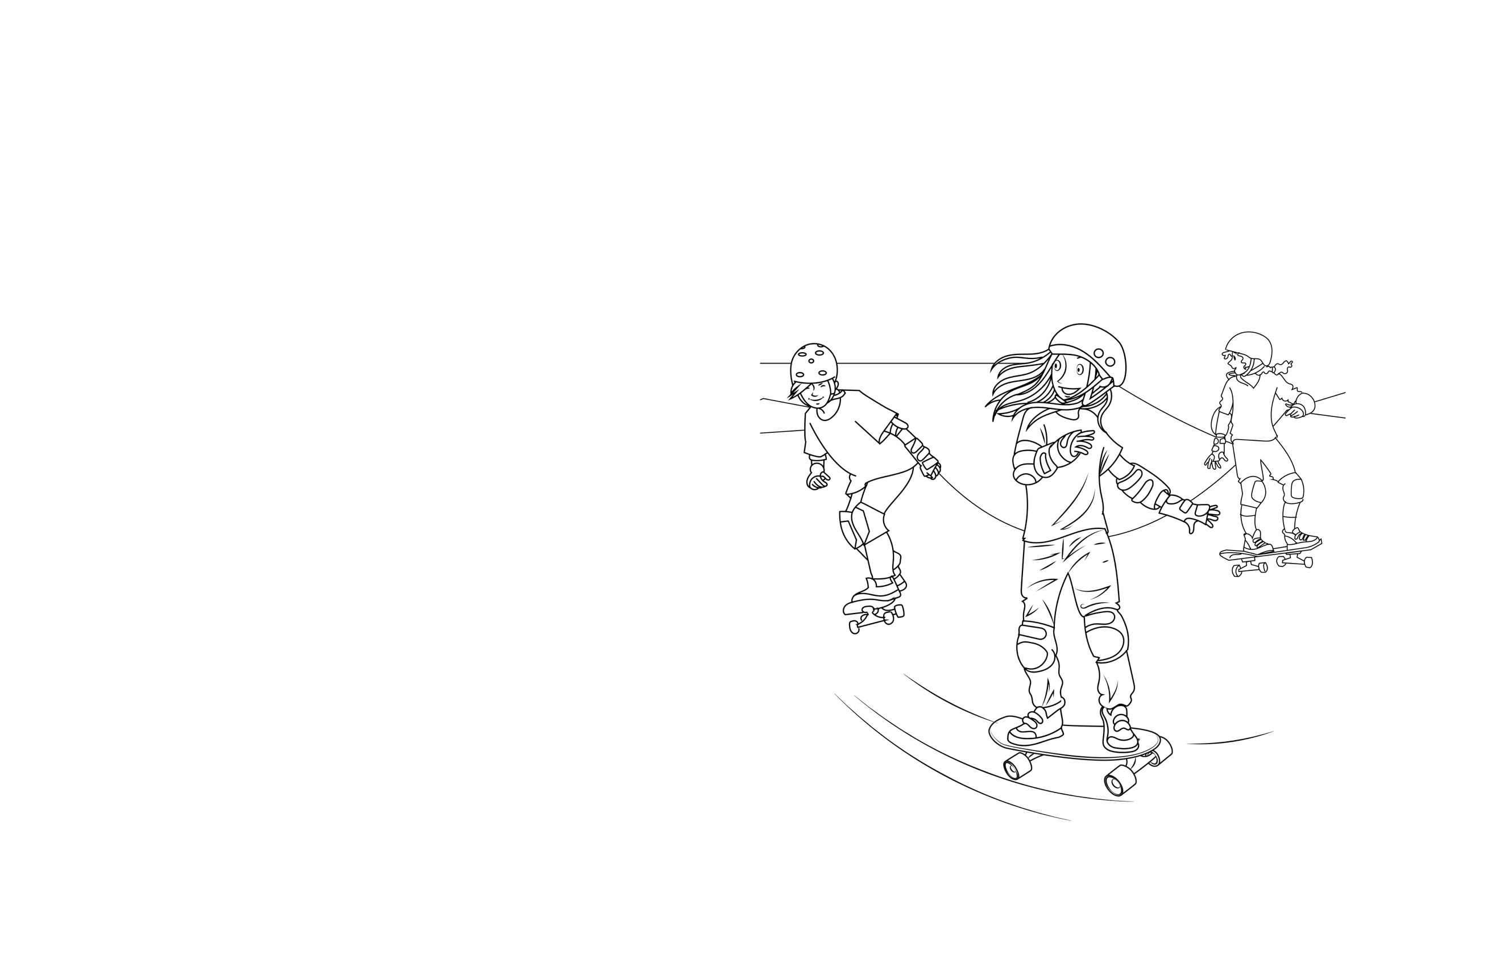
I’m going to tell you about my new skateboard. My mom bought it for me last week for my birthday. It has four wheels and when I stand on it I can
go very fast. At first, I couldn’t find my balance. I kept falling off! But now,
I can stay on it and I can go forwards and backwards, and I know how to stop. I want to ride my skateboard to school, but my mom won’t let me.
She says it is too dangerous and that
I have to walk or take the bus to school. So now, on Saturdays, I go to the skateboard park with my friends. It’s great because I’m learning new tricks!
1 How long has Kia had her skateboard?
A More than a year
B More than three months
C Less than three months
2 Did she find it easy to learn to ride her skateboard?
A Not at first.
B Yes, it was immediately easy.
C No, and she still can’t ride it.
3 Why can’t she ride it to school?
A It’s too far.
B It isn’t safe.
C She can’t ride it yet.
4 Where does she ride her skateboard?
A At home
B At school
C At a special park
5 What is Kia learning now?
A How to do new tricks
B How to go faster
C How to balance

Write the missing words. Write one word for each gap.
3
Last week, Colin went to (1) _________________ dentist. He was very nervous,
so he went with his dad after school. Colin eats a lot (2) _________________ candy. Sometimes this gives him toothache. The dentist looked at his teeth for
a long time. But luckily, he (3) _________________ have any cavities. However,
the dentist did tell Colin that his teeth needed cleaning. The dentist also told Colin
(4) _________________ stop eating so much candy! When Colin left the dentist’s office, his teeth were white (5) _________________ shining. He put his hand in his pocket and pulled out some candy. They passed a trashcan and Colin threw the candy away!
Look at the three pictures. Write the story shown in the pictures.
Use 35 words or more.
4
 |  | 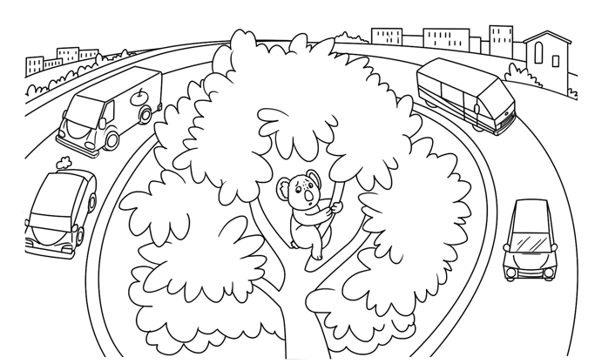 |  | 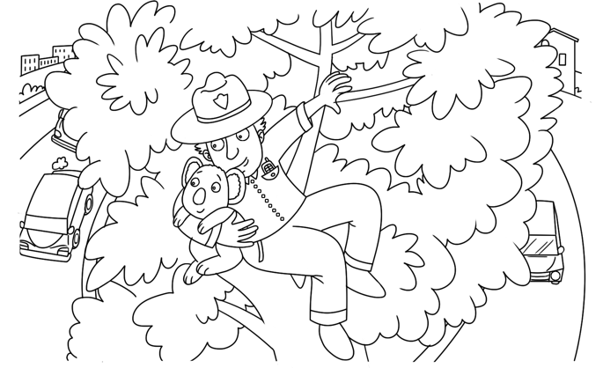
 |  |  | 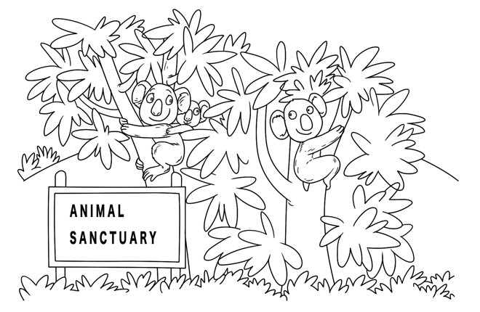
_________________________________________________________________
_________________________________________________________________
_________________________________________________________________
_________________________________________________________________
_________________________________________________________________
_________________________________________________________________
_________________________________________________________________
_________________________________________________________________

Your teacher will ask you questions about some pictures of different wild animals. You will work with a partner to talk about the topics.
5
 | 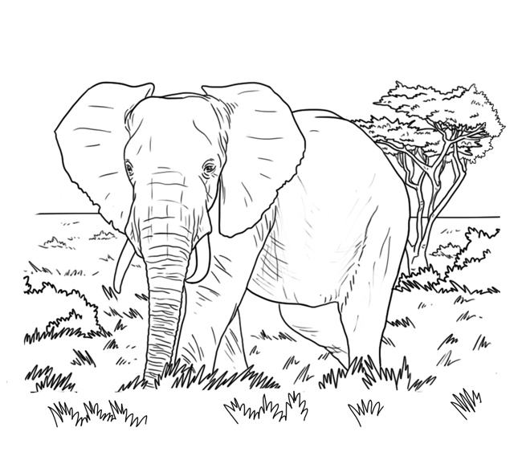 |  |  | 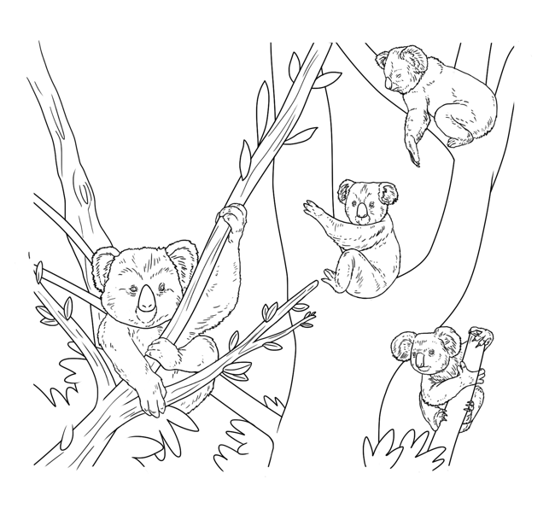
 |  |  |  | 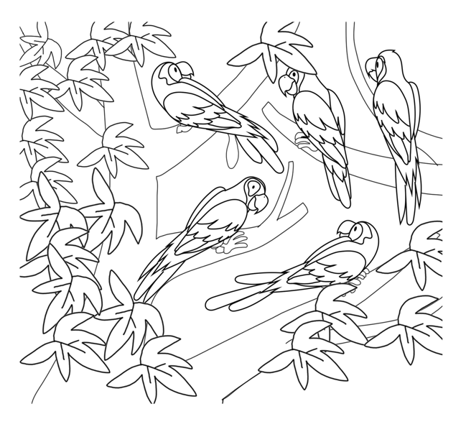
 |  | 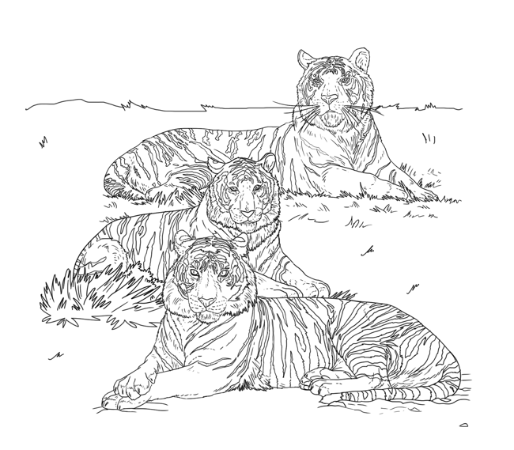

You will hear a teacher telling students about a school camping trip.
Listen and write one word, a number, a date, or a time in the gaps.
You will hear the recording twice. 6
1
School Camping Trip
1 Cost of trip: ________________
2 Travel by: ________________
Day of departure: ___ _Tuesday__ __
3 Time to arrive at school: ________________
4 Day of return: ________________
5 Item to bring: ________________

Read the text and circle the correct answers.
24
By Charlie Exton, Age 10
Last weekend, my family went to the mountains for two days. We stayed in a house
in a beautiful valley. My cousins came with us so there were a lot of people. It was great fun. On Saturday, we climbed a small mountain! We started at nine o’clock in the morning and we walked up the mountain paths all day, looking at the plants
and crossing lots of streams. We took water and sandwiches with us, and we reached the summit at one o’clock. We had lunch at the top of the mountain and looked at the view. It was amazing as there weren’t any clouds at all. Then we walked back down. On Sunday, we were tired so we swam in the lake and had a picnic. What
a great weekend!
1 Where did Charlie and his family stay?
A At the bottom of the mountain
B On the mountain
C At the top of the mountain
2 How long did it take Charlie to climb the mountain?
A Two hours
B Four hours
C Six hours
3 What did they take with them when they climbed the mountain?
A Flashlights
B Ropes
C Food and drink
4 Why did Charlie enjoy the view?
A It was a clear day.
B They could see the valley below.
C It was raining.
5 Did they climb the mountain again on Sunday?
A No
B Yes
C Don’t know

Write the missing words. Write one word for each gap.
3
Animals communicate (1) _________________ many different reasons.
Sometimes they tell each other where (2) _________________ find food.
Sometimes they tell each other not to come any closer. A lot of animals,
such as baboons and chimpanzees, live (3) _________________ small groups,
and they don’t like other animals coming into their habitats. When other animals
do come in, they can make noises to warn their family members and to make
(4) _________________ other animals go away. In this way, they communicate
(5) _________________ feelings through sound. The sound will be different
for different animals. For example, parrots squawk and baboons and
chimpanzees grunt.
You are going on vacation with your family and you are inviting your cousin, Vincent. Write an e-mail to Vincent.
4
Say:
where you are going
when you are going
what you want to do there
Write 25 words or more.
_________________________________________________________________
_________________________________________________________________
_________________________________________________________________
_________________________________________________________________
_________________________________________________________________
_________________________________________________________________
_________________________________________________________________
_________________________________________________________________
_________________________________________________________________
_________________________________________________________________
_________________________________________________________________

Your teacher will ask you questions about some pictures that show different ways people express themselves. You will work with a partner to talk about
the topics.
5
 |  |  |  |  | 
 |  | 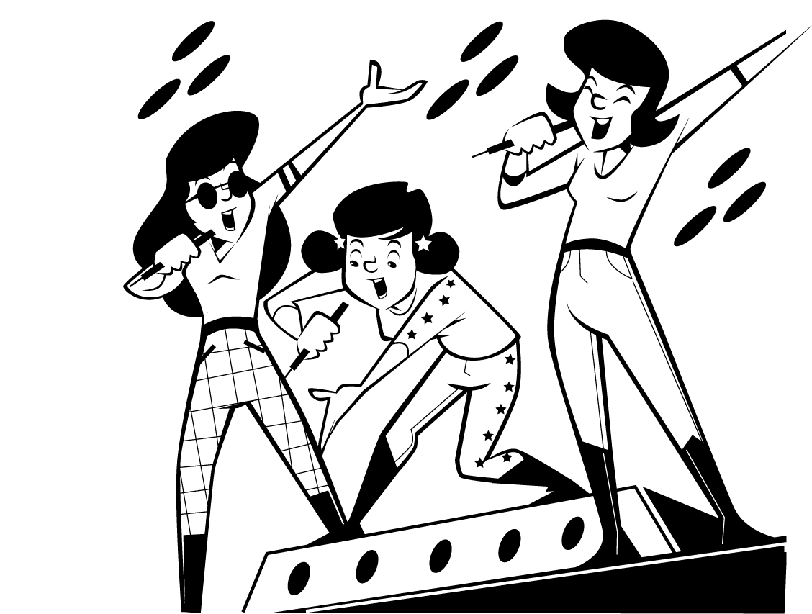 |  |  | 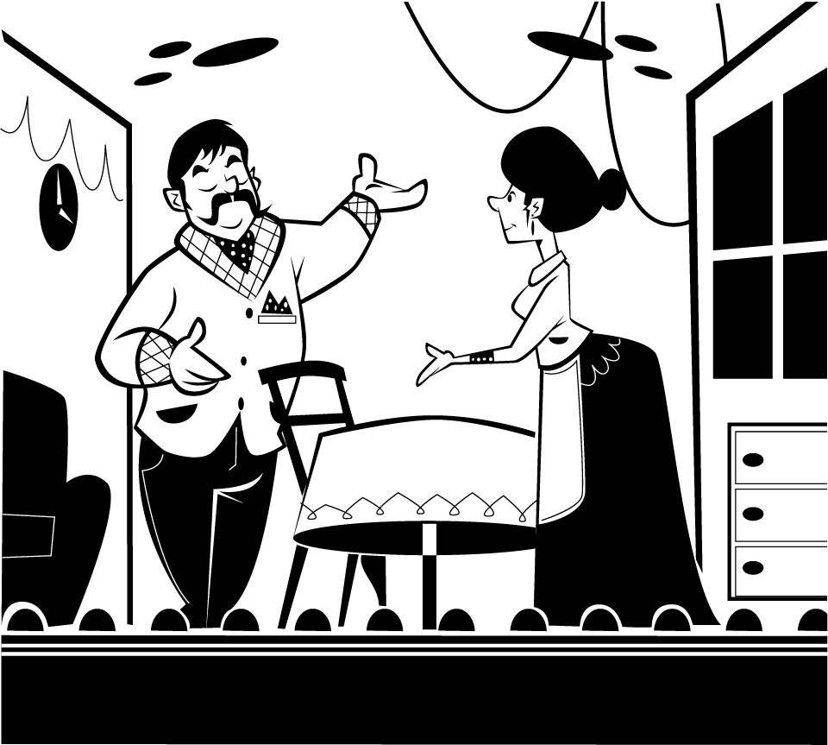
 |  |  | 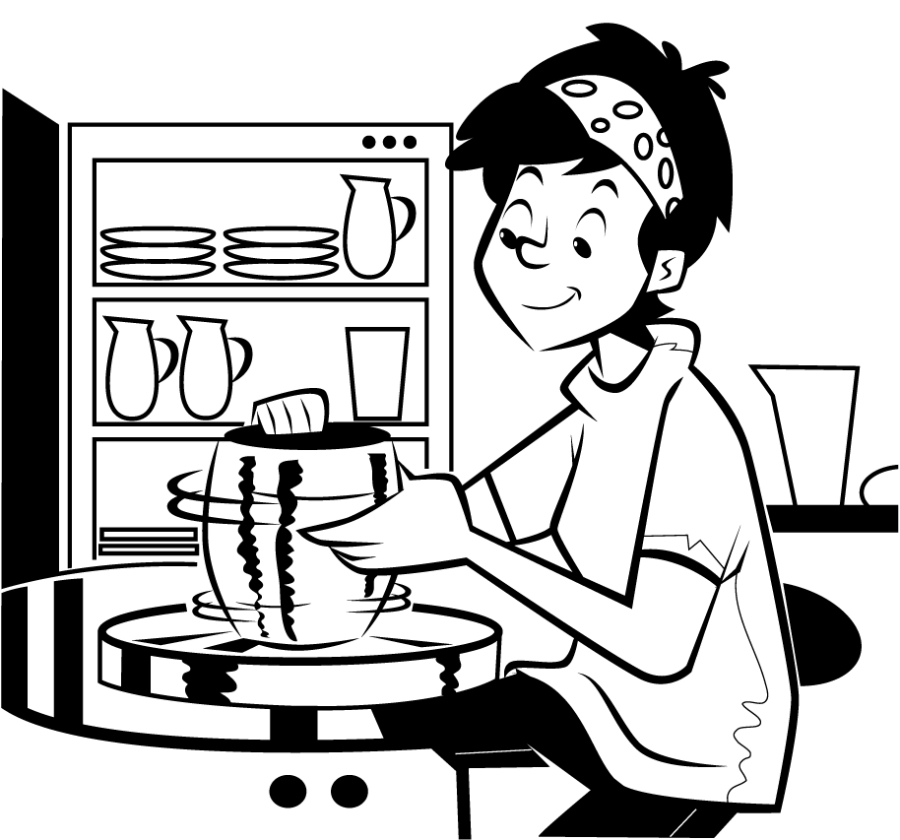
You will hear Brett talking to his friend about his art class. Listen and, for each question, circle the correct letter. You will hear the recording twice. 7
1
1 How often does Brett go to his art class?
A Once a week
B Twice a week
C Every day
2 What does he like about his art teacher?
A She makes learning art fun.
B She’s a talented artist.
C She does different things each week with the students.
3 What did Brett make in art class today?
A A sculpture
B A mosaic
C A painting
4 What feelings did his art express?
A Joy
B Sadness
C Excitement
5 What is Brett’s favorite type of art?
A Painting
B Pottery
C Drawing

Read the text and circle the correct answers.
2
By Felix Stroud, Age 11
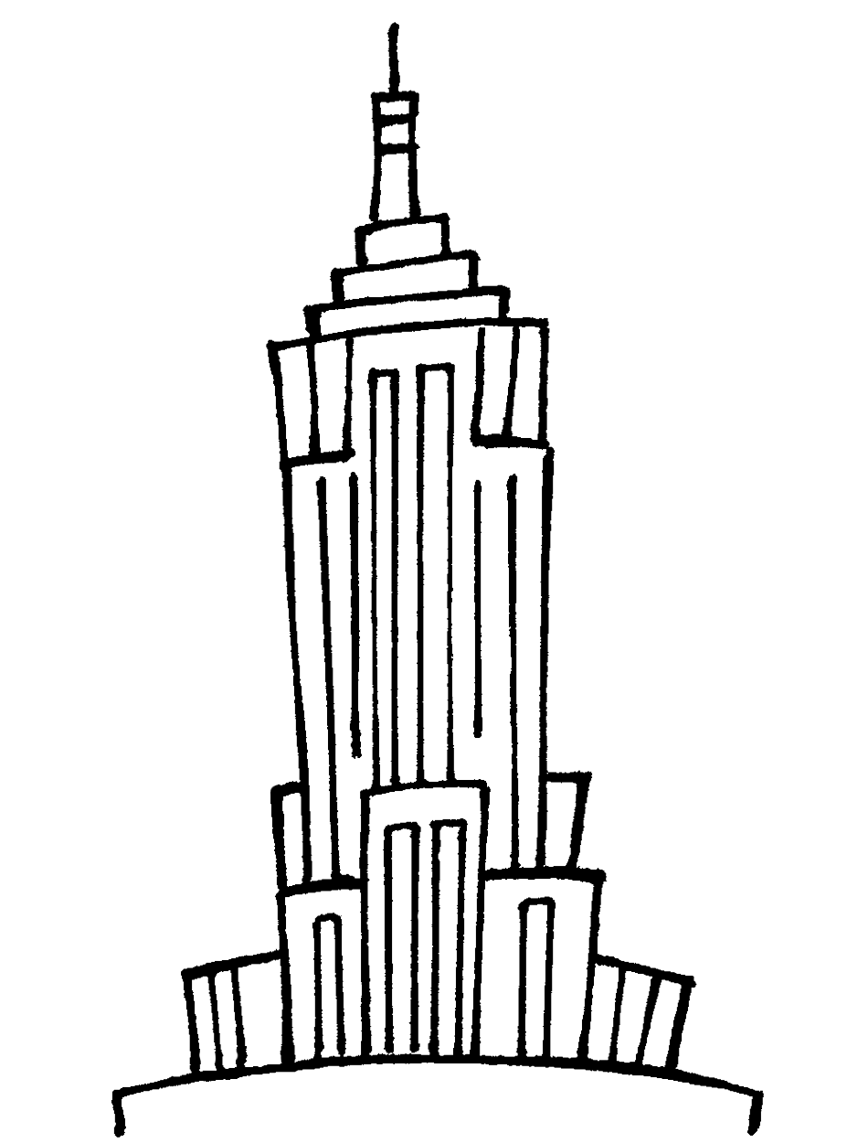
Tomorrow, I’m going with my dad to visit the Empire State Building. It’s in New York, near
where I live. The Empire State Building is
102 stories high. It took fourteen months to
build and it was completed in 1931. They built one storey every week! We are going up to the very top of the building to see the view over New York,
so I hope it is a clear day tomorrow. It used to be the world’s tallest building, but it isn’t anymore. However, over 4 million people visit it every year because it is so famous. It’s been in a lot of movies and TV shows. I can’t wait to go!
1 How tall is the Empire State Building?
A Under 150 storeys
B Under 100 storeys
C Under 50 storeys
2 How long did it take to build the Empire State Building?
A Less than one year
B Less than two years
C Less than five years
3 Why is Felix going to the top of the building?
A He likes to climb up high places.
B He wants to see the view.
C He is going to a restaurant on the top floor.
4 Is the Empire State Building the tallest building in the world?
A No
B Yes
C We don’t know
5 Why do so many people visit the Empire State Building?
A It is well-known.
B It’s very new.
C They live there.

Write the missing words. Write one word for each gap.
3
Isabella (1) _________________ been saving up to buy a scooter for a long time.
She gets $5 pocket money (2) _________________ week. She spends $2 on magazines and comics. She spends $2 on games, and she saves $1 a week.
She’s been saving now (3) _________________ a whole year. She has over $50.
She’s going with her mom and her best friend, Kim, to the store tomorrow to pick
the scooter that she wants. She’s been looking online at the different types for the past three months. She wants one (4) _________________ blue and green handles. She’s (5) _________________ to ride it home!
You are going to see a play with your friend, Janet. Write an e-mail.
4
Say:
what time you will meet
where you will meet
why you are looking forward to seeing the play.
Write 25 words or more.
_________________________________________________________________
_________________________________________________________________
_________________________________________________________________
_________________________________________________________________
_________________________________________________________________
_________________________________________________________________
_________________________________________________________________
_________________________________________________________________
_________________________________________________________________
_________________________________________________________________

Your teacher will ask you questions about some pictures of different places in the world. You will work with a partner to talk about the topics. / 10
5
 | 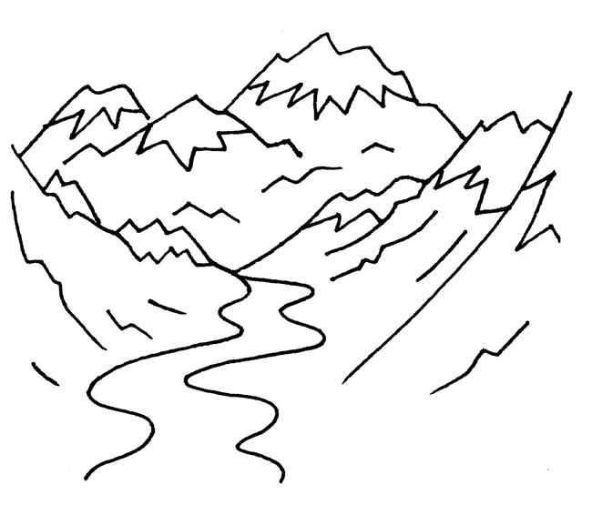 |  |  | 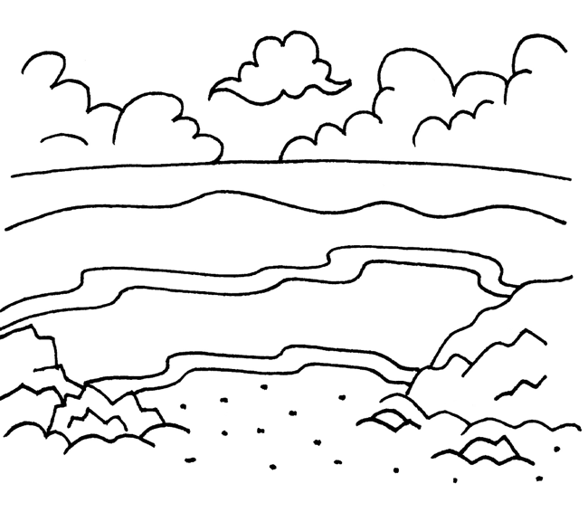
 | 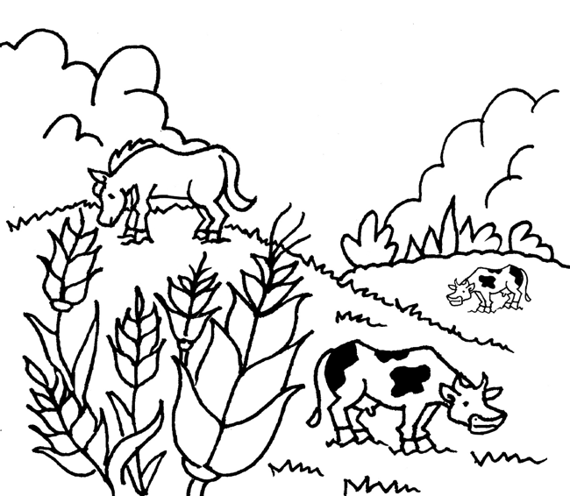 |  |  | 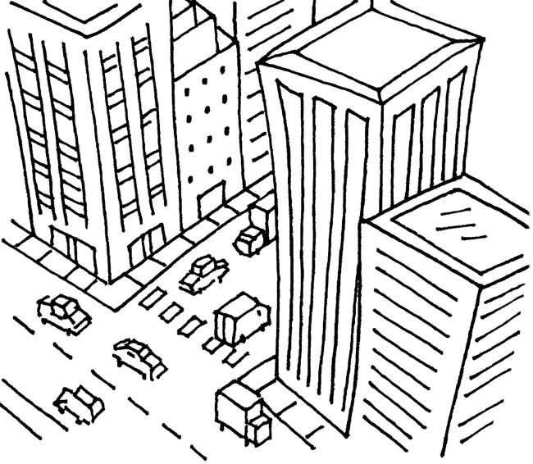
 |  | 

