Name _____________________________ Date ____________________________________

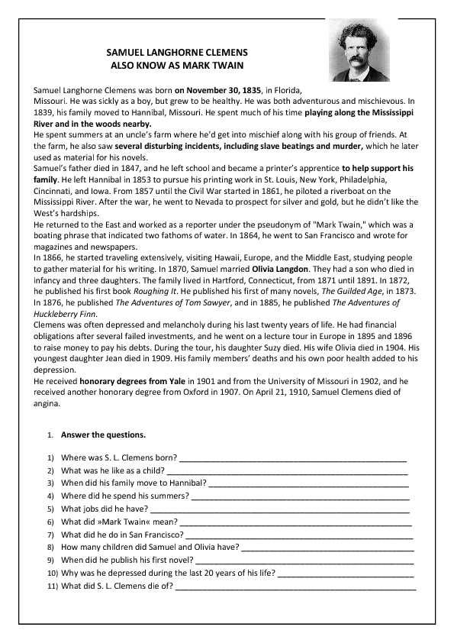Reading Comprehension